

**Bachelor of ICT Assessment Cover Sheet**

Complete and attach this cover sheet to your assessment before submitting

**Course Code and Title:**

IT7405 – Web development using Non-relational Databases

**Assessment Title:**

**Learning Outcomes:**

LO1 – Demonstrate critical knowledge and understanding of the fundamental concepts and techniques of Data Mining

LO2 – Utilize data mining software to solve defined and undefined problems

LO3 – Interpret and evaluate obtained numerical and graphical data to recommend the best model to be used for prediction purposes

Individual Project

**Student ID**

202000270

**Student Names:**

Ameena Adel Mohammed Almohanna

**Tutor:**

Sini Raj Pulari

**Due Date:**

Wednesday, 20th Dec 2023 by 11:55 p.m.

**Late Rule:**

**The maximum grade granted for late submission is 60 % for up to 2 calendar days. A grade of 0 will be allocated for submission after 2 days**

***By submitting this assessment for marking, either electronically or as hard copy, I confirm the following:***

* *This assignment is* ***my own work***

#### Any information used has been properly referenced.

* *I understand that a copy of my work may be used for moderation.*

#### I have kept a copy of this assignment

Do not write below this line. For Polytechnic use only*.*

**Assessor:**

**Date of Marking:**

**Grade/Mark:**

Page **1** of **6**

**Table of Contents**

**Task 1 – Problem Statement Formulation and definition** 3

Motivation - Business Goals 3

Project Definition - Problem Statement 3

Functionalities 3

**Task 2 - Creating the No-SQL MongoDB Database and Data Modeling** 4

Creation of a No-SQL MongoDB 4

CRUD operations 4

• Create 4

• Read 5

• Update 6

• Delete 7

Data type used and Data modelling concepts 8

Usage of MongoDB Index 9

Query Diagnosis and Analysis 9

**Task 3 - Using Django to build the Web Application using Bootstrap** 13

a) Creation of VirtualEnv for Django 13

b) Project settings used. 18

c) Connectivity of Django with MongoDB 21

d) Templates 22

e) Model Template 33

f) View Template 34

g) Django Admin site 39

h) Django forms 40

i) Incorporation of Bootstrap 44

**Task 4 – Overall GUI and working, Report, GIT hub, Video and Reflection** 47

Overall Navigational GUI 47

Working of Web Application meeting all Functionalities 47

Report 51

GIT hub 51

https://github.com/ameena212/ChapterOneBookStore 51

Video 51

Reflection 51

# **Task 1 – Problem Statement Formulation and definition**

## Motivation - Business Goals

##### Traditional bookstores face unique challenges to remain relevant and accessible in today's digital world which is rapidly evolving and changing. Regardless of literature's vast and timeless nature, bookstores must adapt to new technology and customer preferences to survive and succeed. "Chapter One" is a bookstore with a large collection of books. It aims to transform the bookstore into a modern library that offers online services to make purchasing easier and provide an opportunity for people to sell their books online so that the bookstore may also buy limited-edition books from them. Consequently, Chapter One will remain a beloved destination for book lovers by combining the charm of a physical bookstore with modern digital shopping conveniences. The aim of this project is to develop a user-friendly web application that will allow bookshops to reach a global audience, manage book inventory efficiently, ensure accurate stock information, and effortless cataloguing at any time, and increase customer interaction.

## Project Definition - Problem Statement

Chapter One operates in a highly competitive market, and its geographical limitations make it difficult to meet readers' demands outside its area. Moreover, it is time-consuming to deal with a wide selection of books manually, where mistakes are more likely to occur. In addition, the store lacks an appropriate platform for engaging with customers and buying books that are valuable, but the owner wants to sell. Additionally, it does not provide 24/7 access to book enthusiasts who prefer digital shopping and readers who prefer to see if the book they want to buy is available before visiting the store.

## Functionalities

1.      Reader registration and login.

2.      Users can add books to sell, and store can add book, delete, update it.

3.      Shopping Cart: add to cart, remove from cart, change quantities, and review selections.

4.      Checkout: entering user data and address to deliver and get a message if purchased successfully.

# **Task 2 - Creating the No-SQL MongoDB Database and Data Modeling**

## Creation of a No-SQL MongoDB

-show dbs

- use chapteroneBookstore

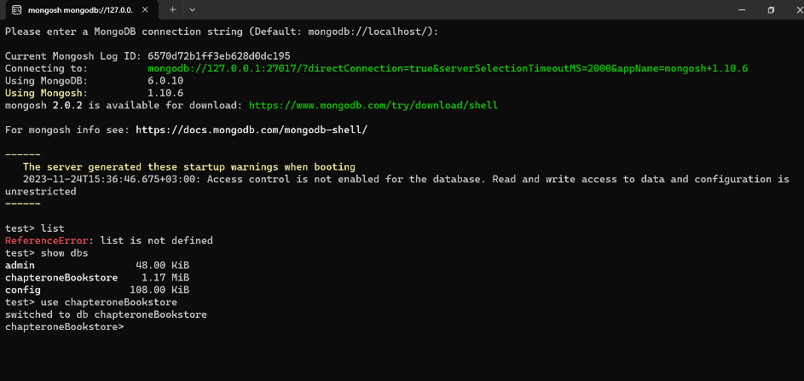

## CRUD operations

### Create

-insert one document

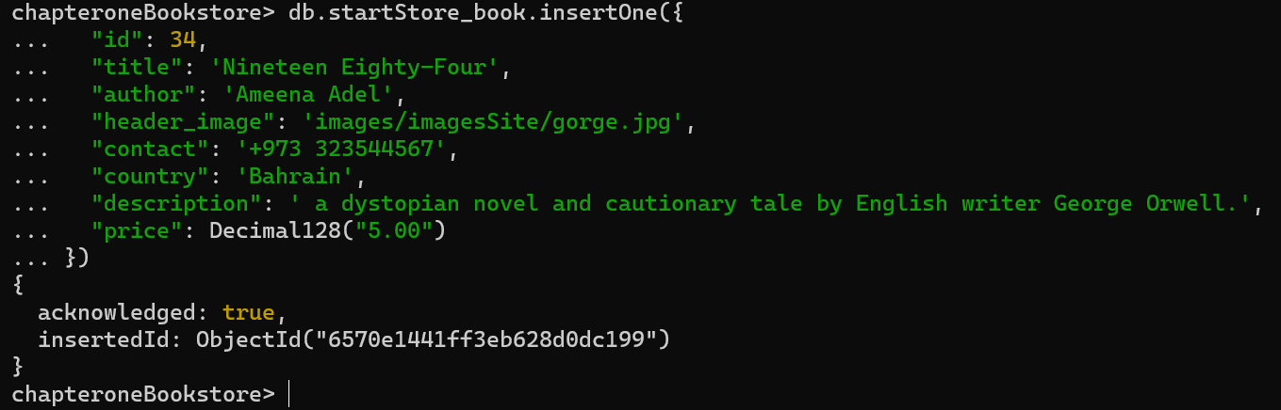

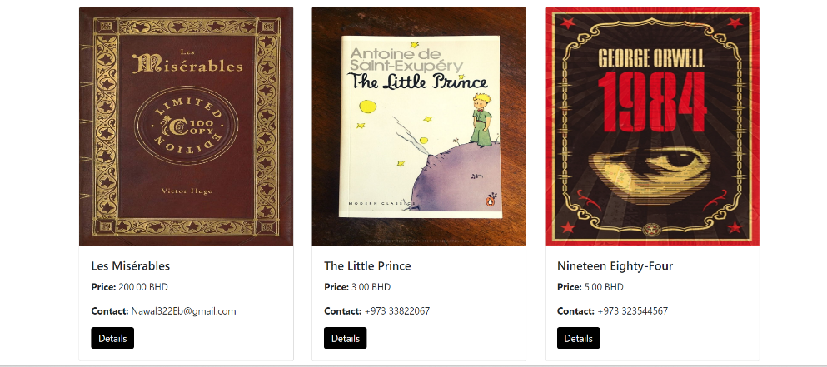

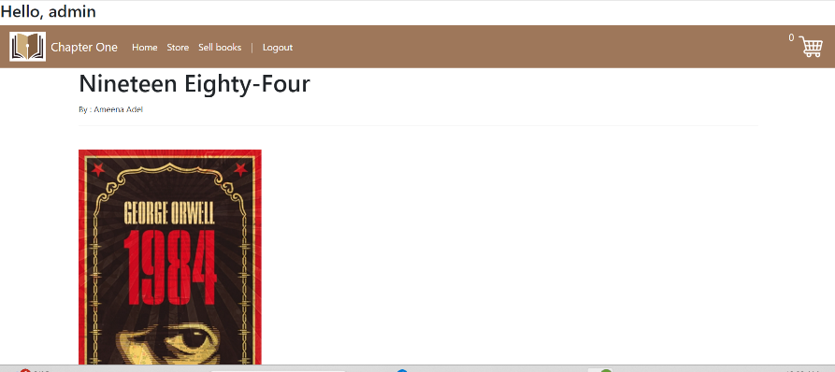



### Read

-show all documents

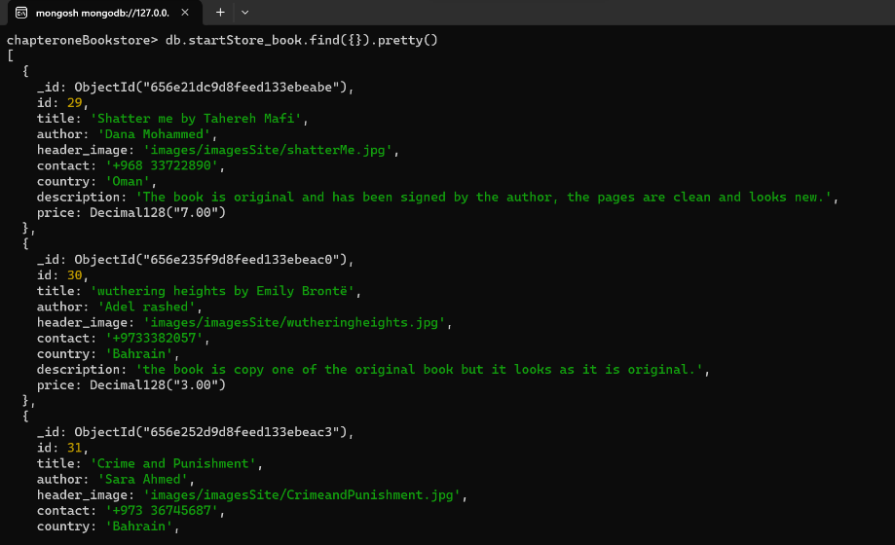

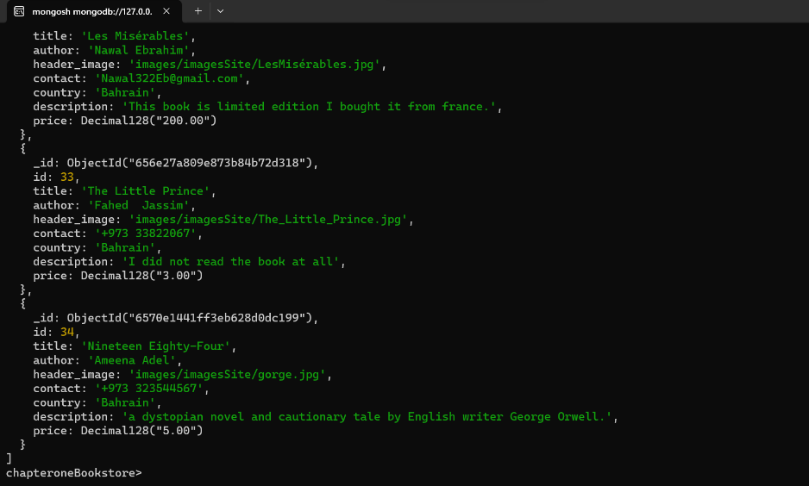

-show using equality matching

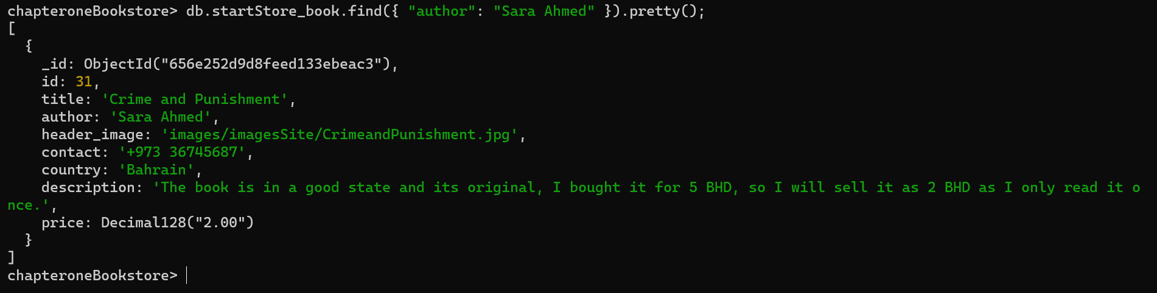

-show using selecting fields

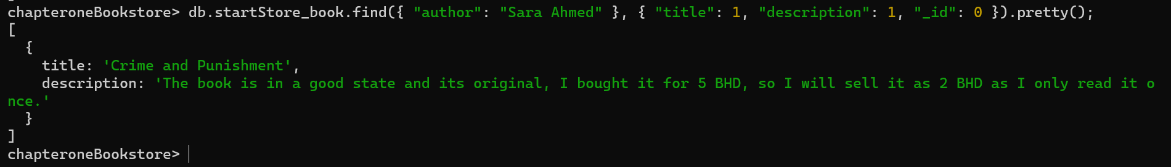

### Update

-update one

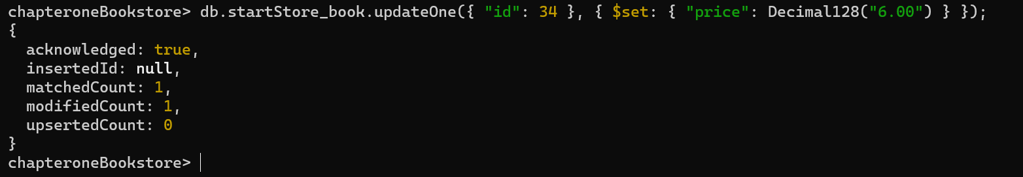

-price changed from 5 to 6.



-update many

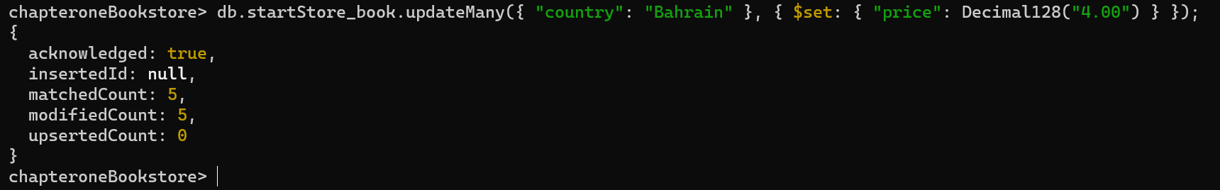

-all countries named Bahrain, changed the price into 4.

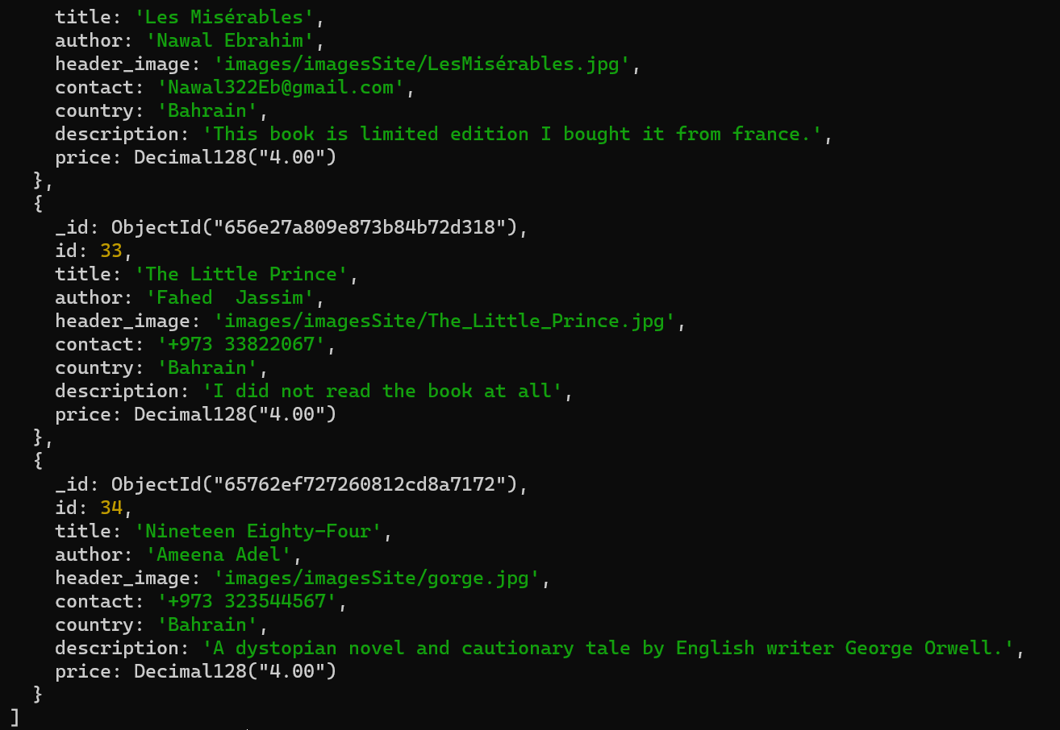

### Delete

-replace one document with id 34 data.

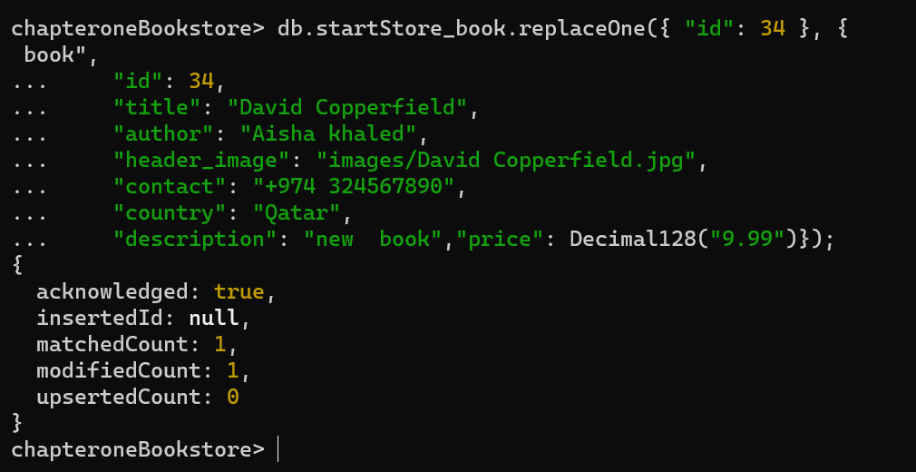

-delete one document with id 34 data.

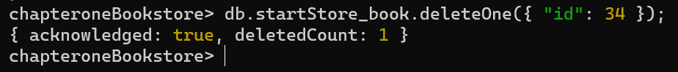

-document is deleted



-delete all document with country named Bahrain



-one document left



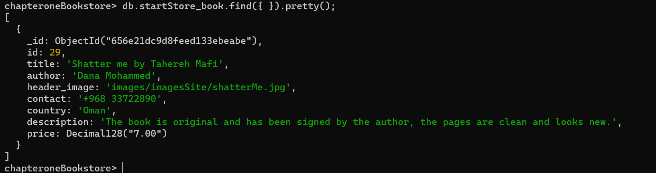

## Data type used and Data modelling concepts

The data types used are String: title, author, header_image, contact, country, and description, ObjectId: _id, Decimal128: price, and Number (Int32): id.

Data modelling concepts are embedded Documents and One-to-One Relationships because all the attributes of a book are contained within each document. It is a self-contained embedded document with various fields such as title.

## Usage of MongoDB Index

-create index for title, get indexes and find it.

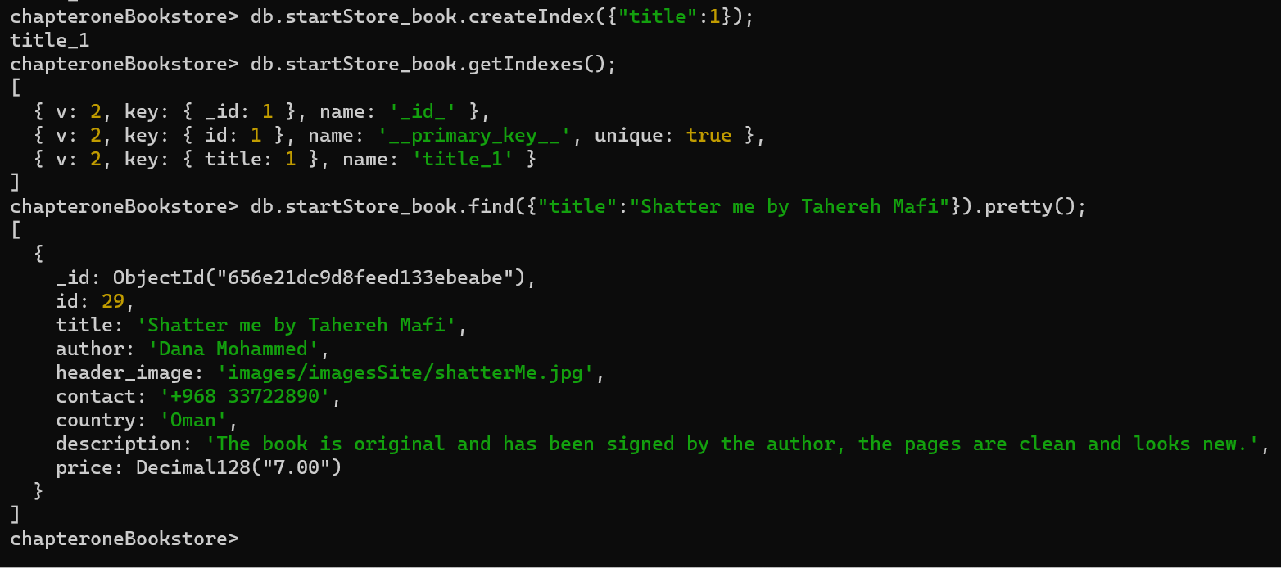

## Query Diagnosis and Analysis

Query Diagnosis 1:

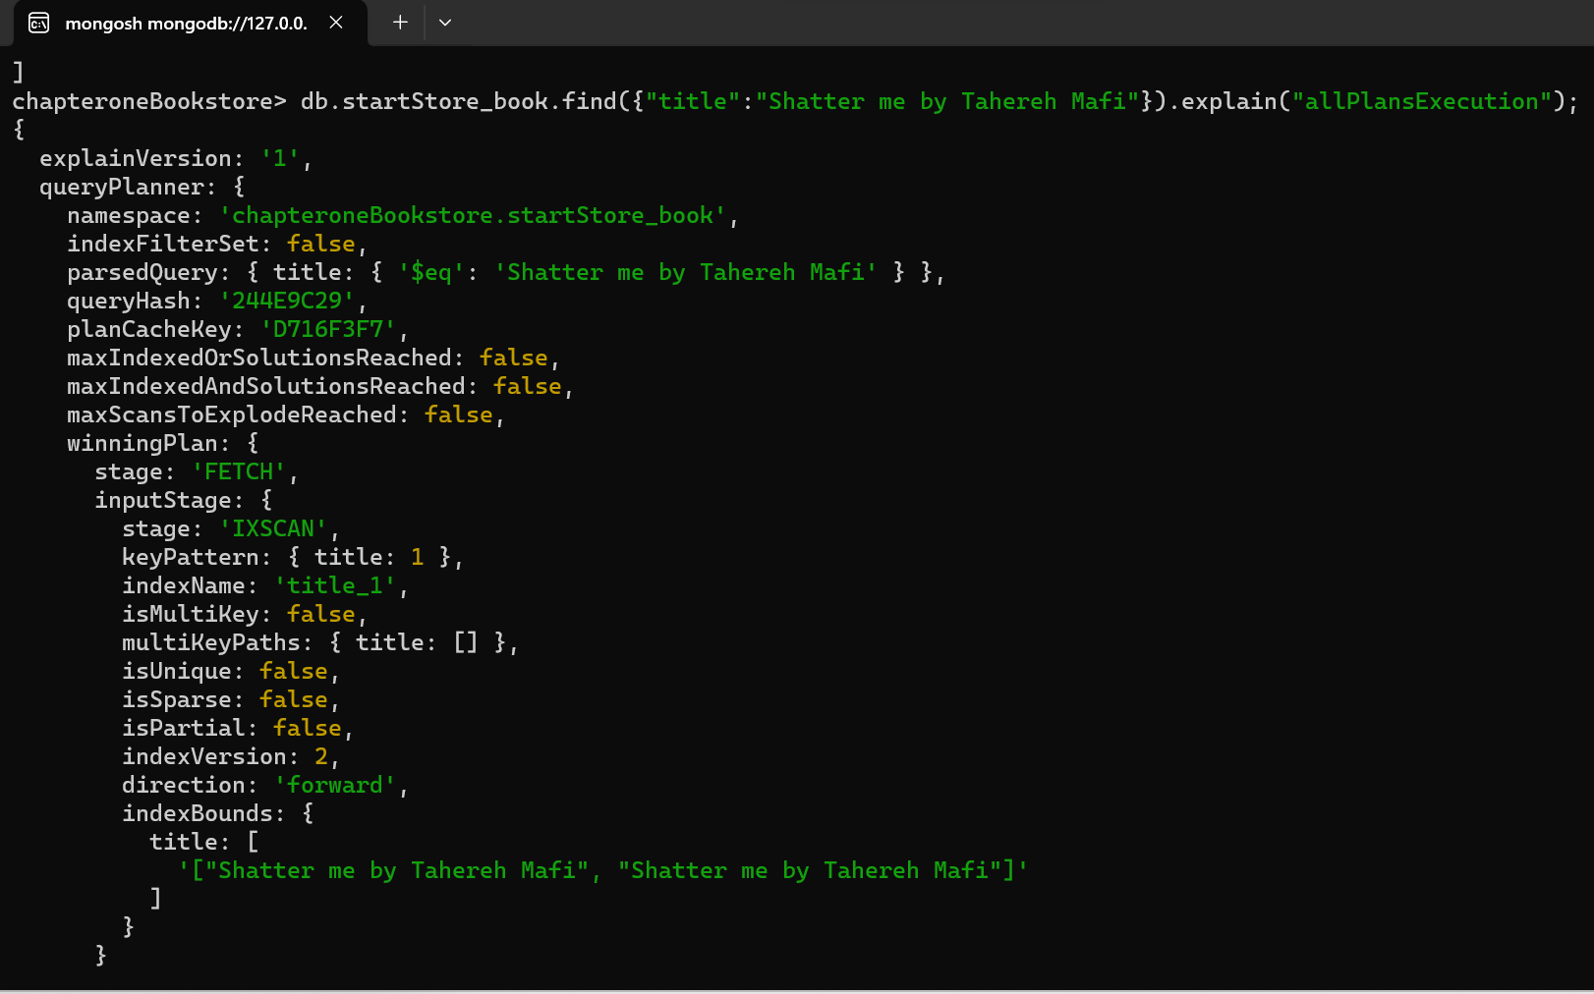

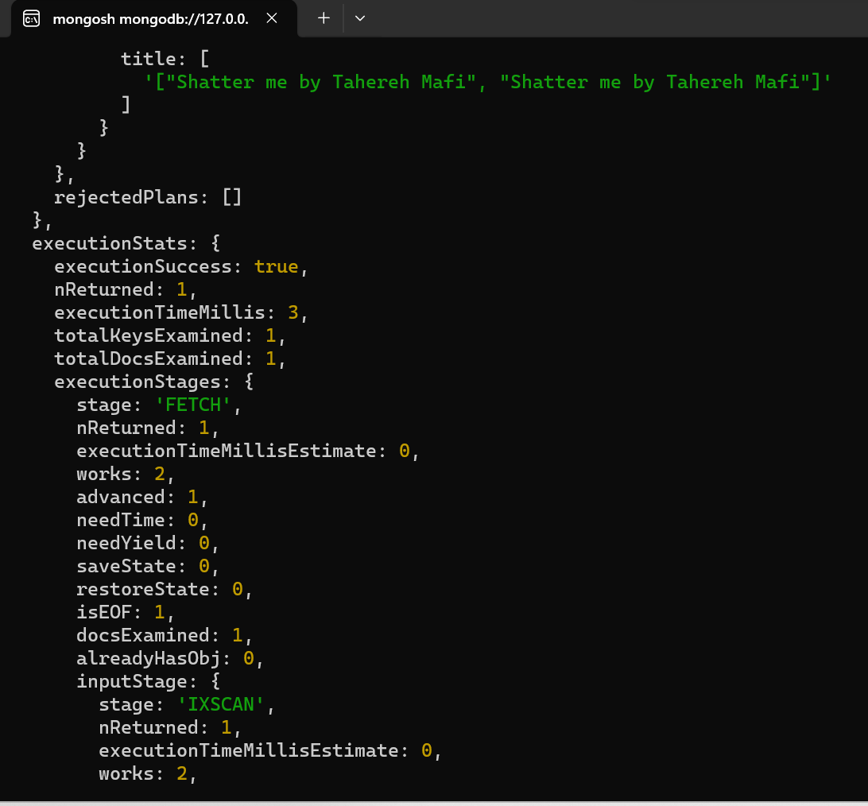

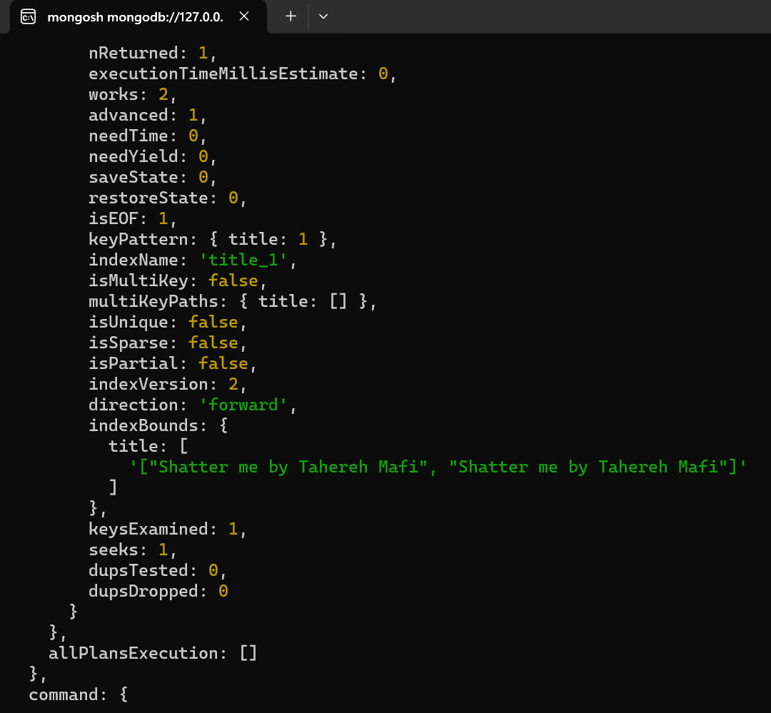

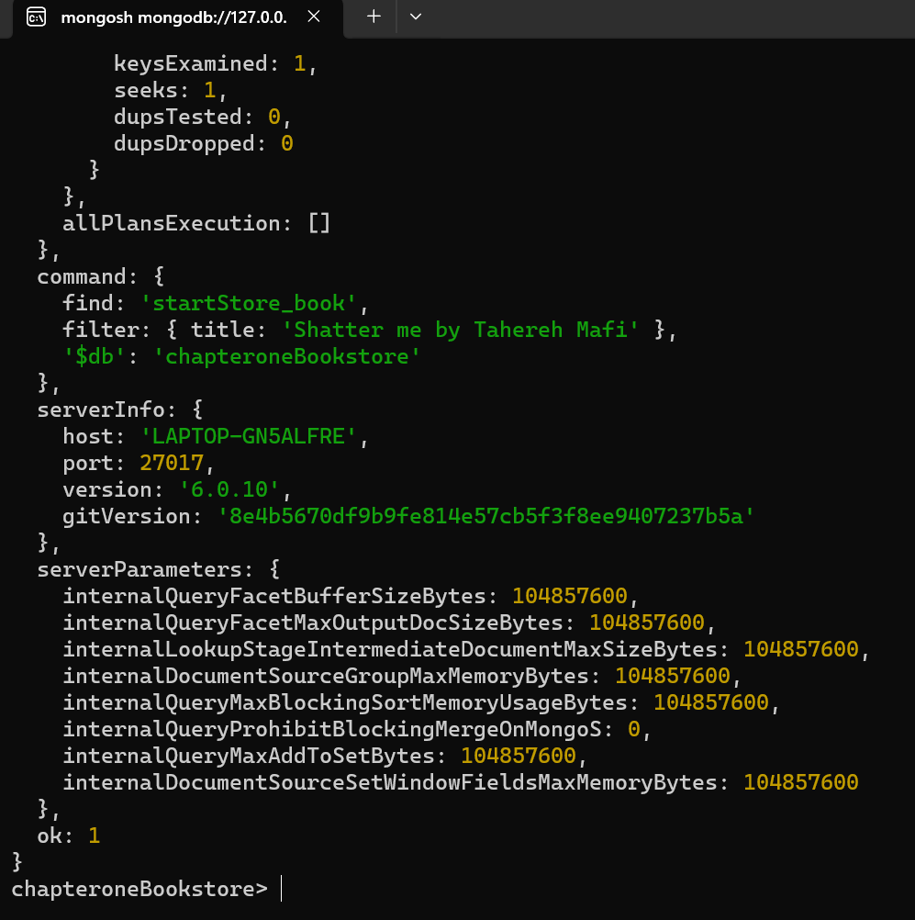

Query Diagnosis 2:

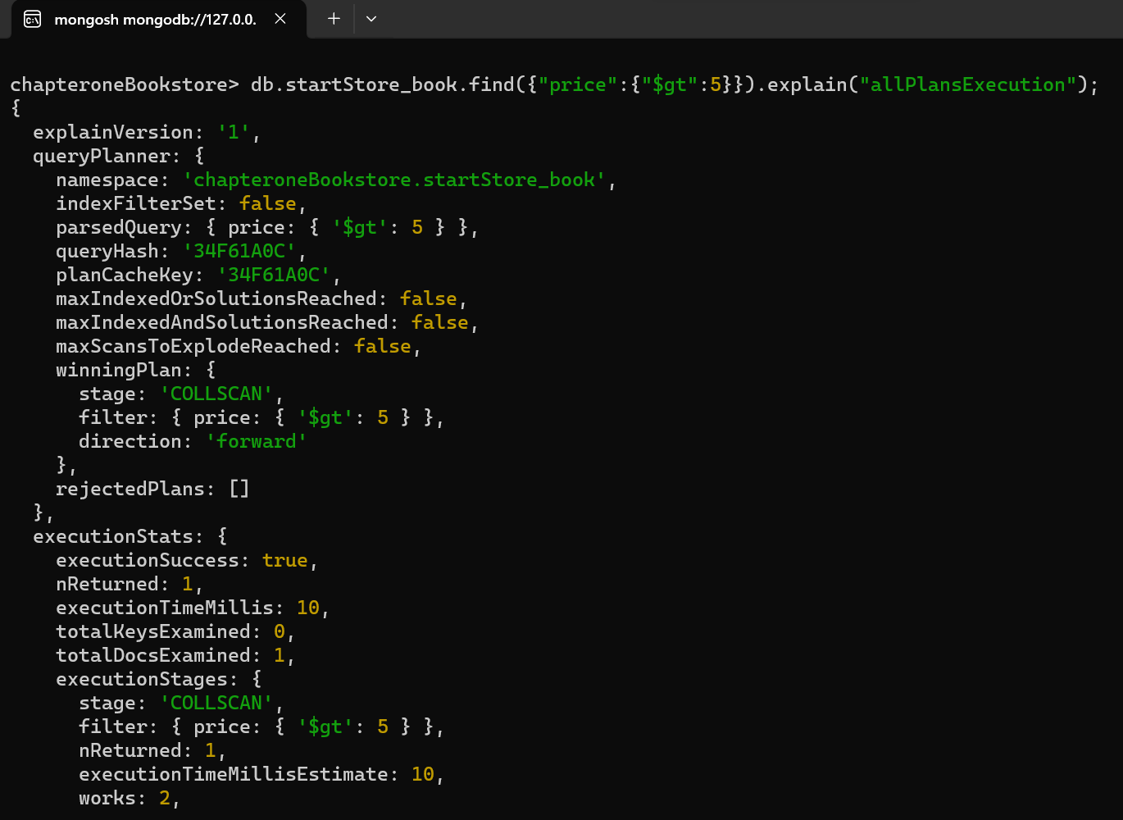

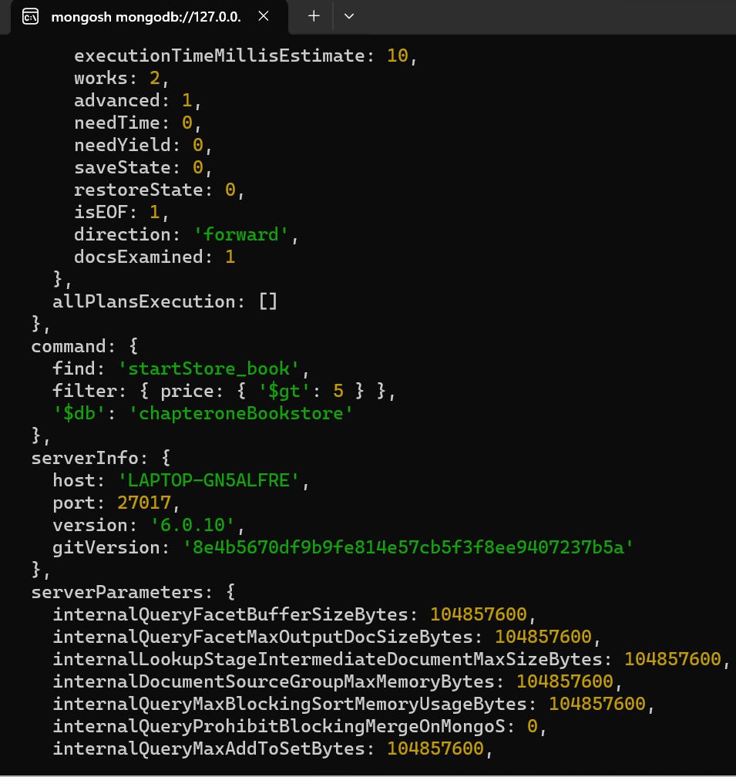

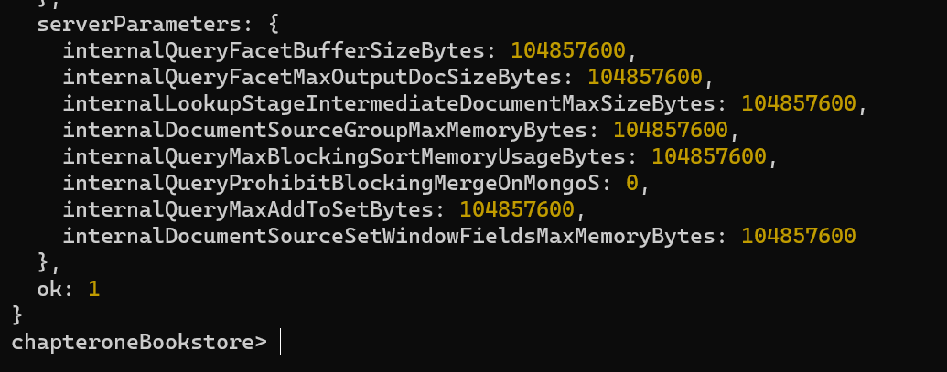

First query:

The query planner used an index scan (IXSCAN) on the title_1 index.

The index bounds indicate that the query scanned for the exact title "Shatter me by Tahereh Mafi."

Second query:

The query planner performed a collection scan (COLLSCAN) without using any indexes.

# **Task 3 - Using Django to build the Web Application using Bootstrap**

Main folder name=django

Virtual name= storeEnv

Project name= chapteroneBookstore

## Creation of VirtualEnv for Django

-cd C:\Users\ameen\OneDrive\Desktop\django

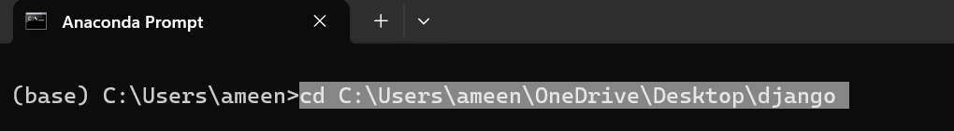

-conda create --name storeEnv django

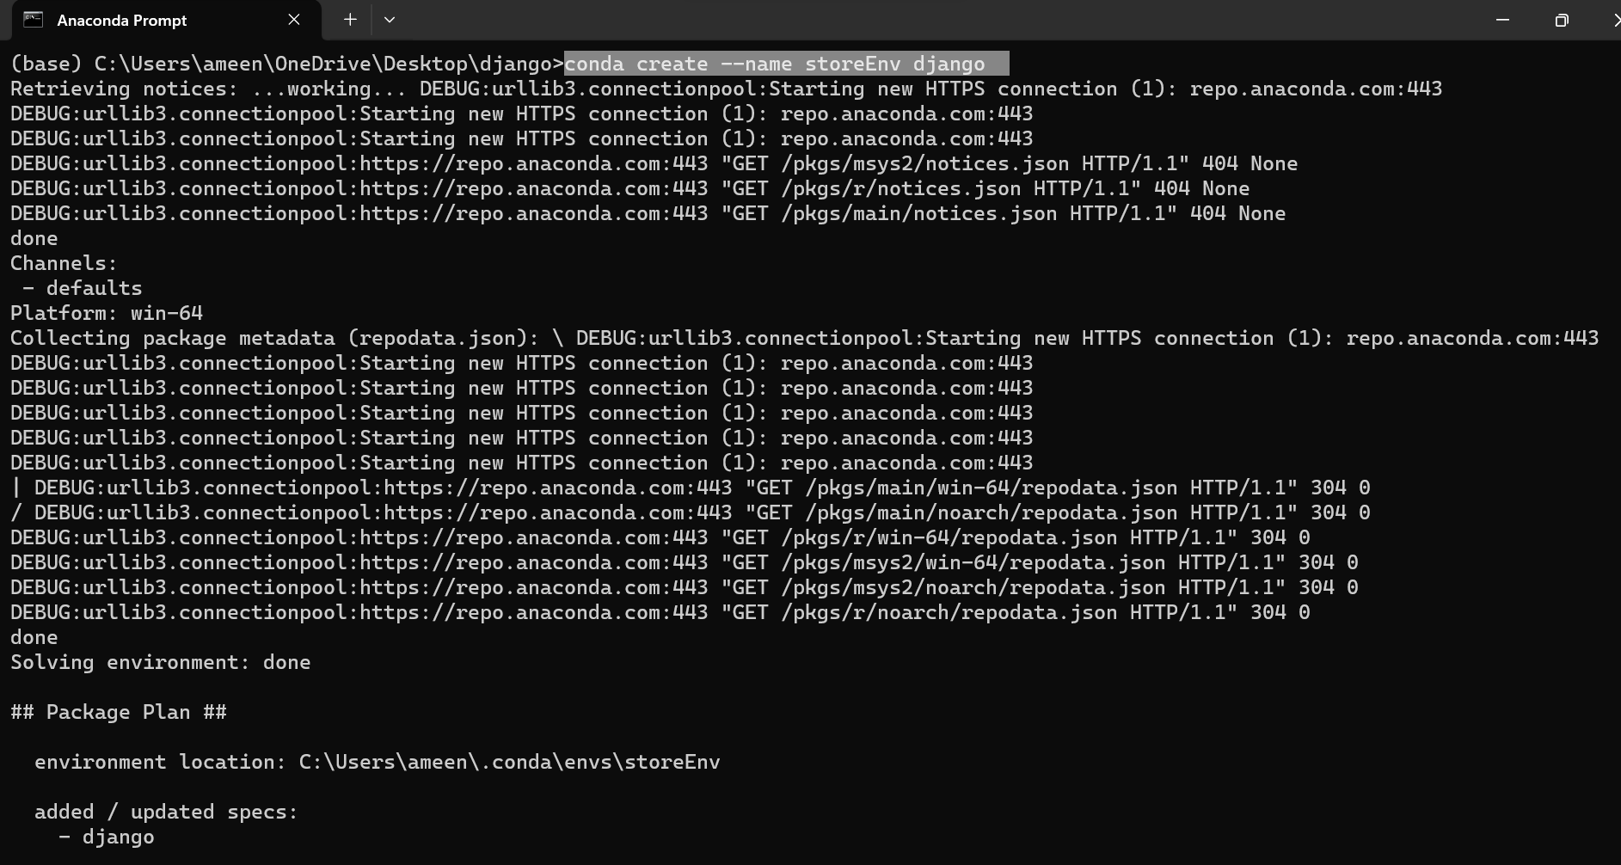

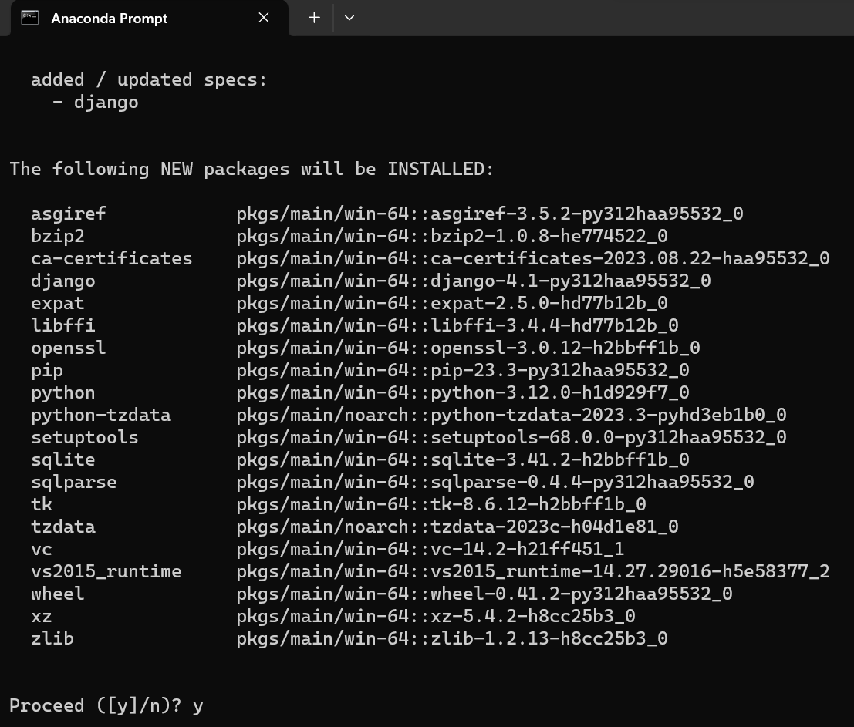

-activate storeEnv

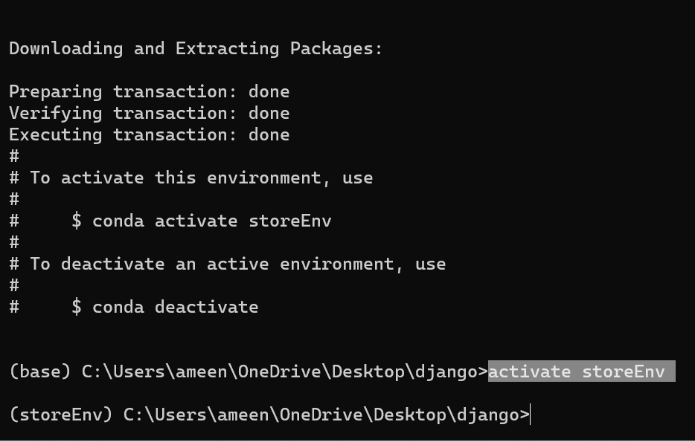

-pip install Django

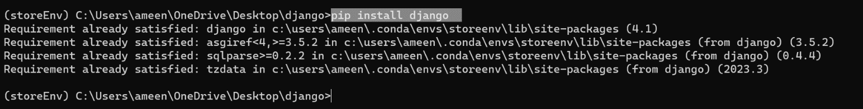

- django-admin startproject chapteroneBookstore



- cd chapteroneBookstore

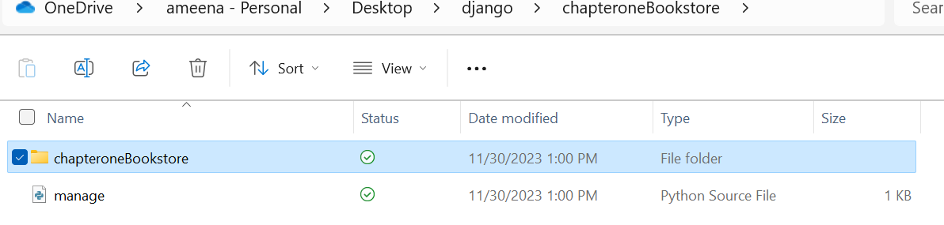

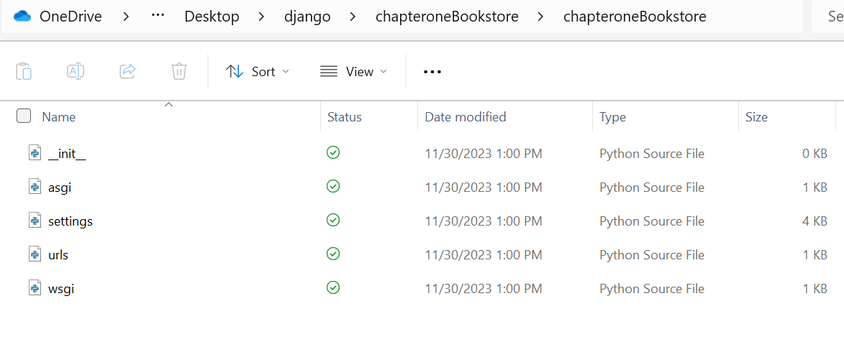



- python manage.py runserver

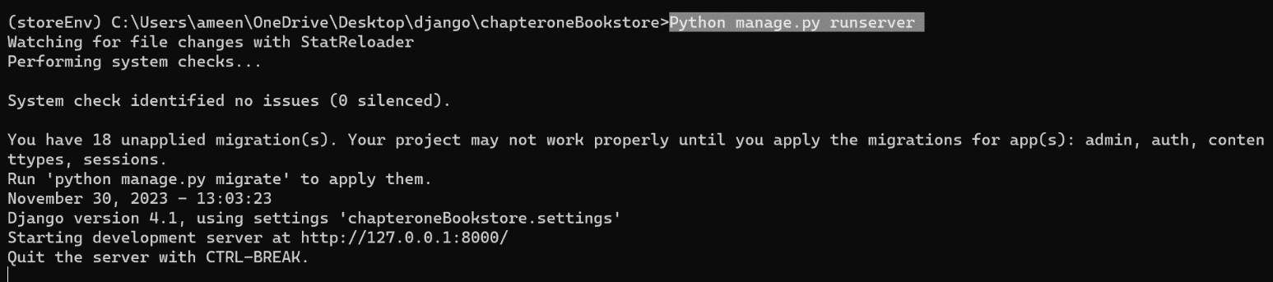

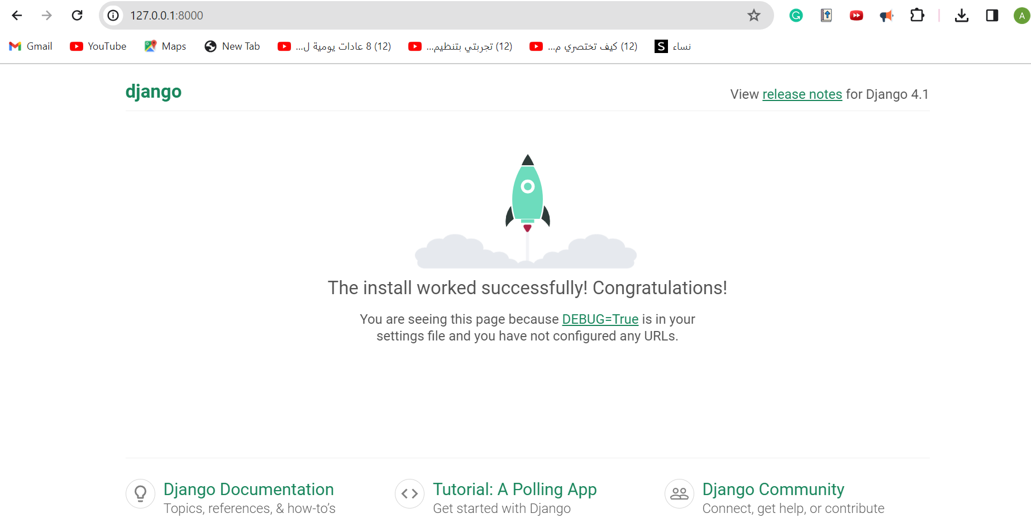

- python manage.py makemigrations



-python manage.py migrate

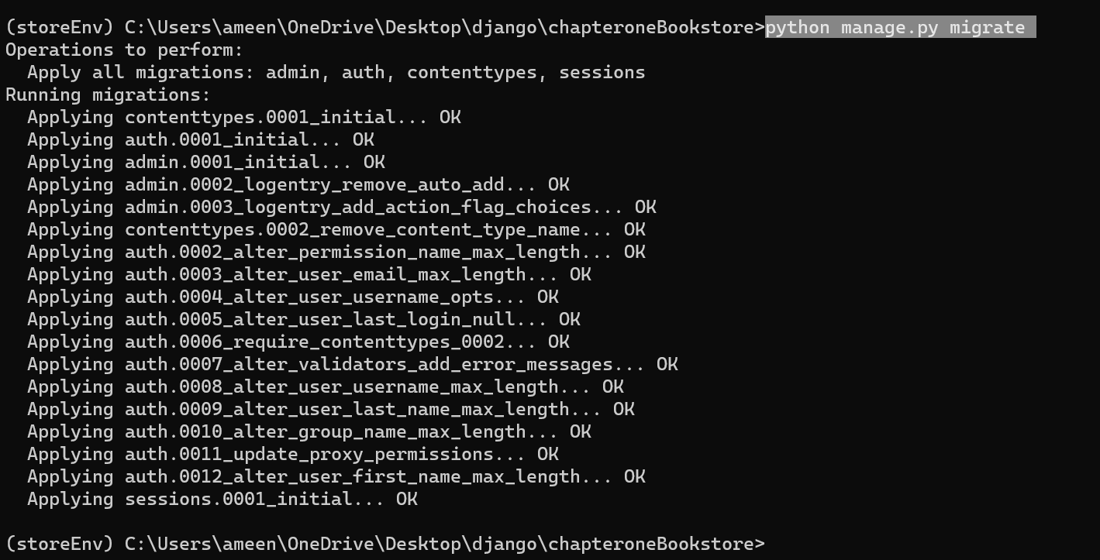

- python manage.py createsuperuser

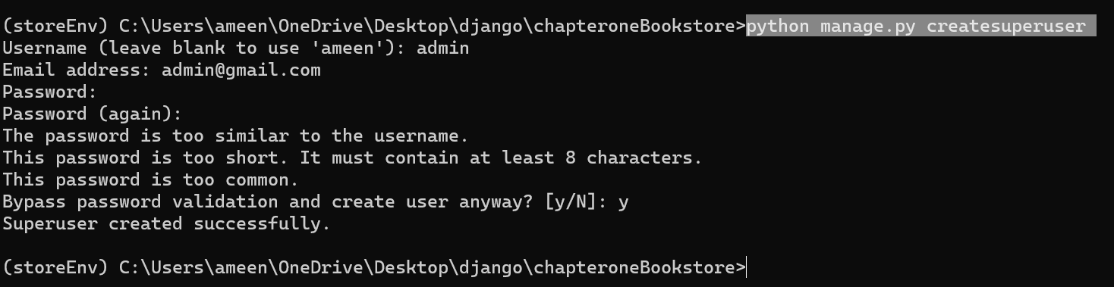

- <http://127.0.0.1:8000/admin/>

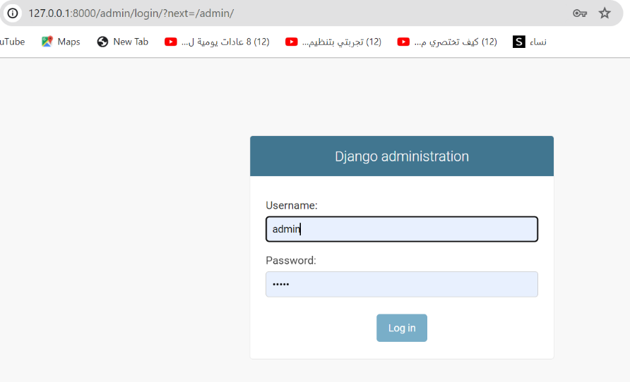

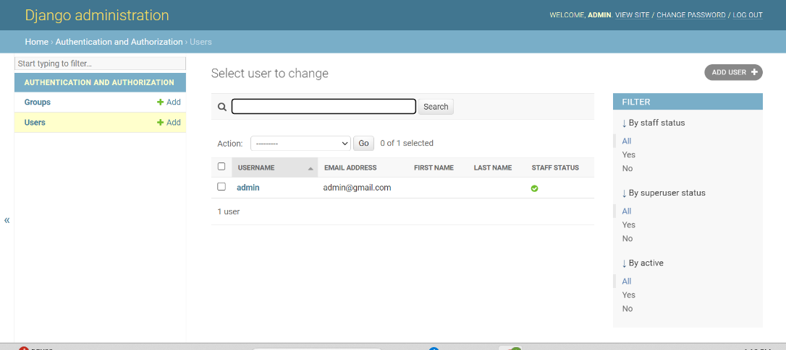

- python manage.py startapp startStore



- python manage.py makemigrations

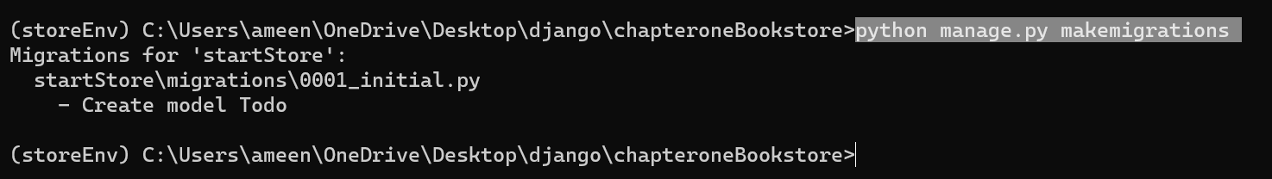

-python manage.py migrate

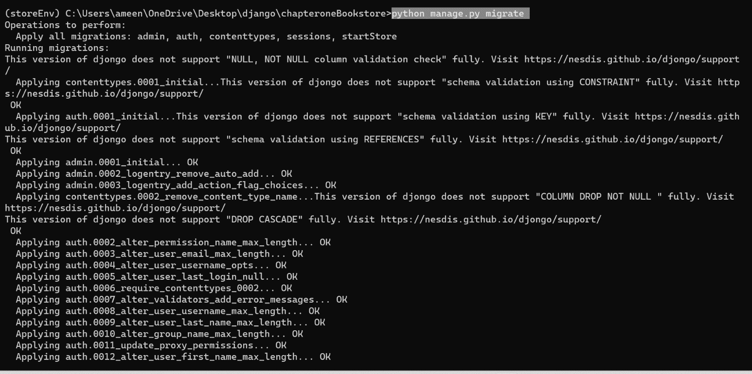

- python manage.py startapp userauth



- python manage.py startapp cart



## Project settings used.

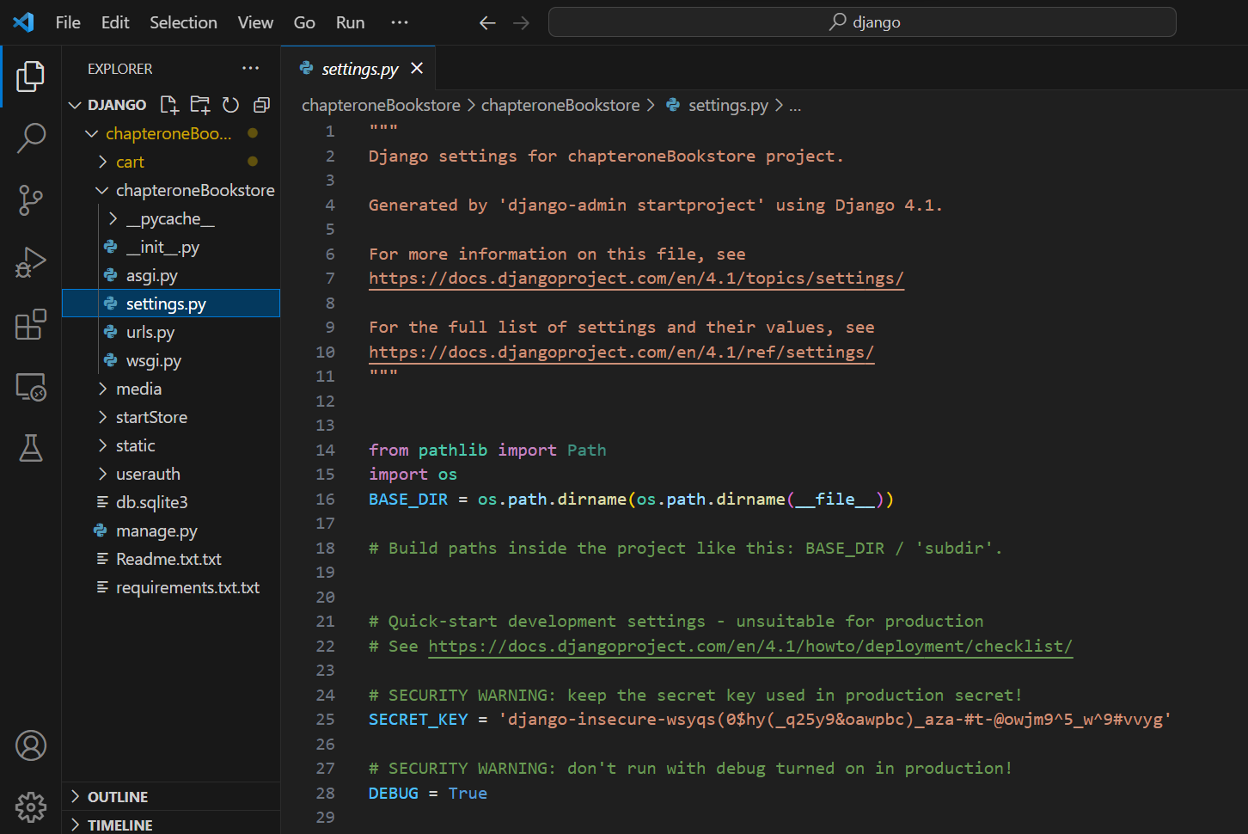

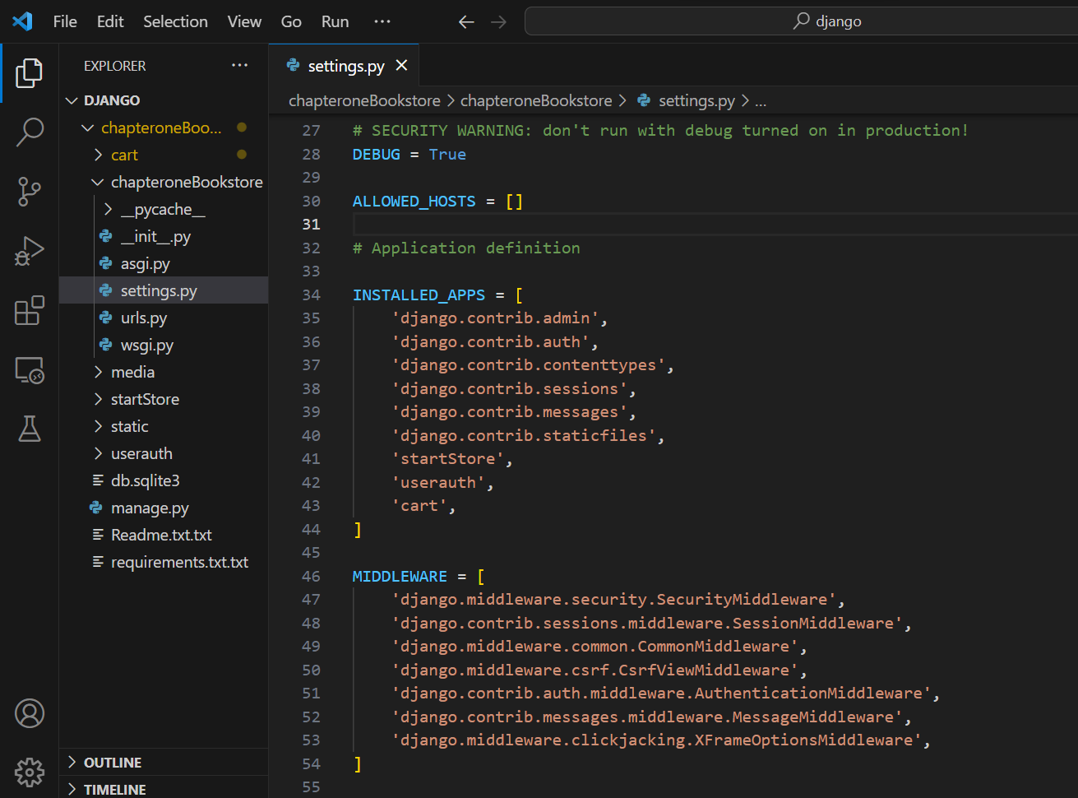

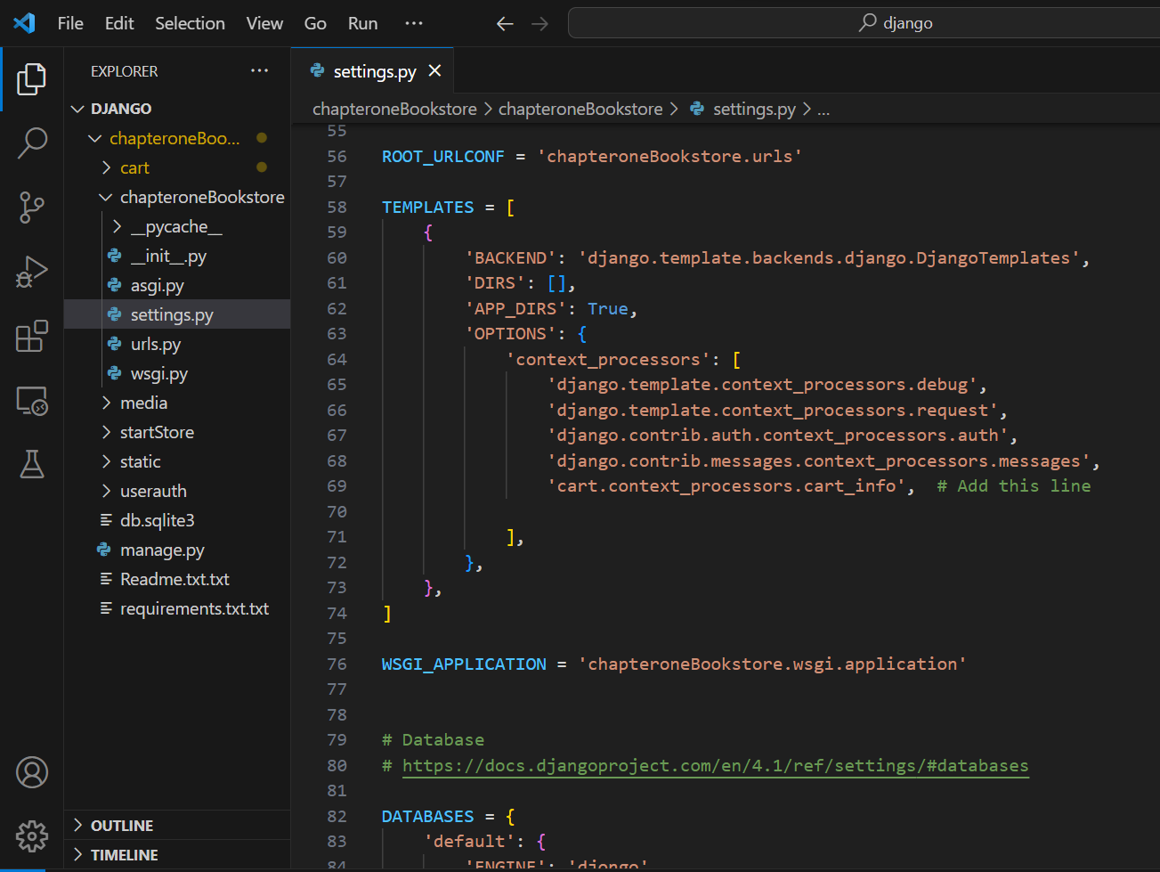

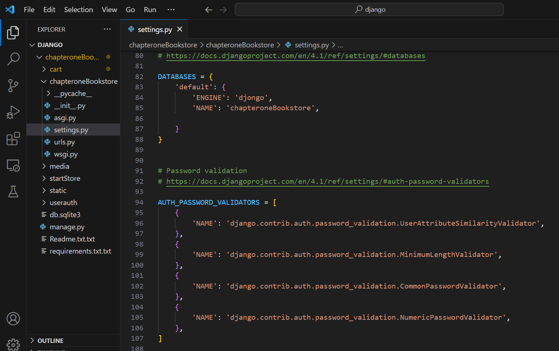

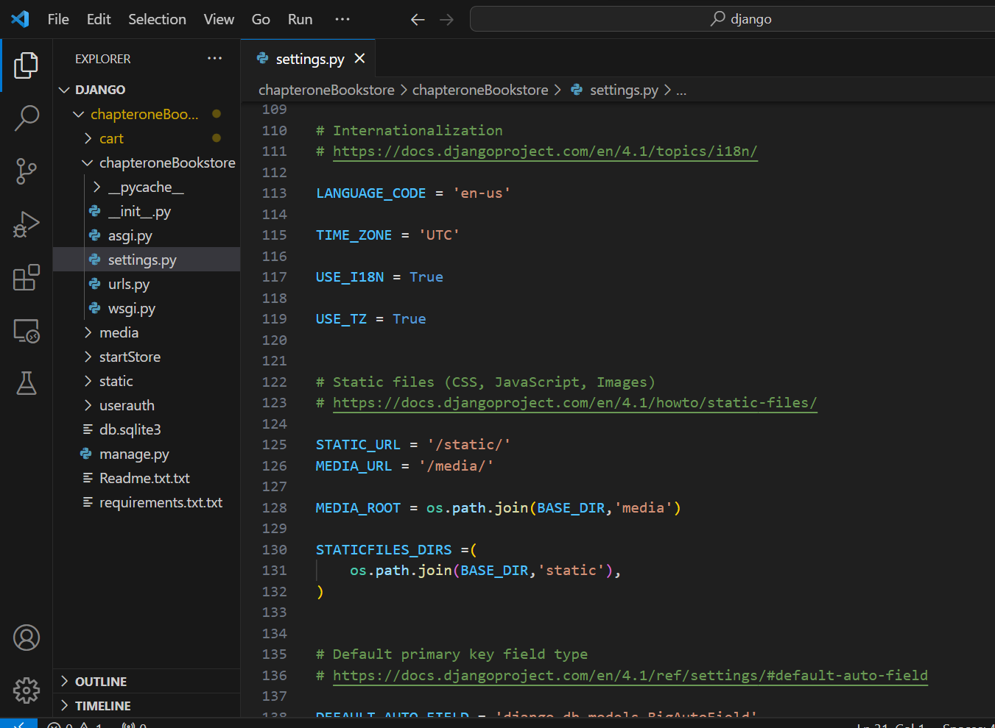

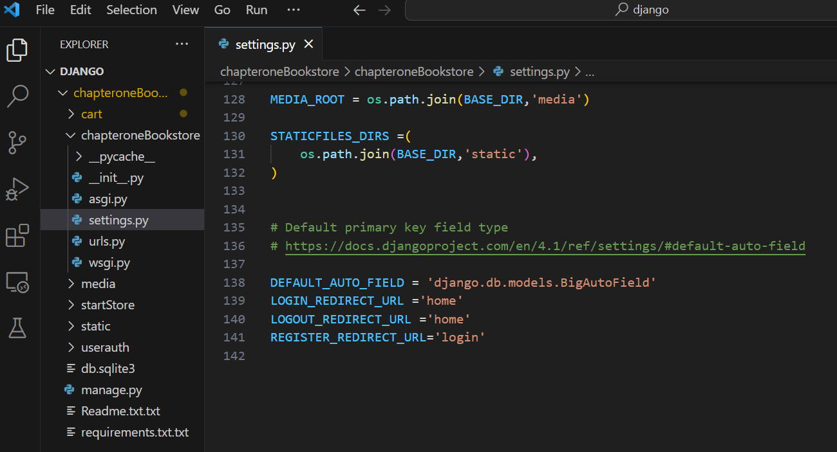

## Connectivity of Django with MongoDB

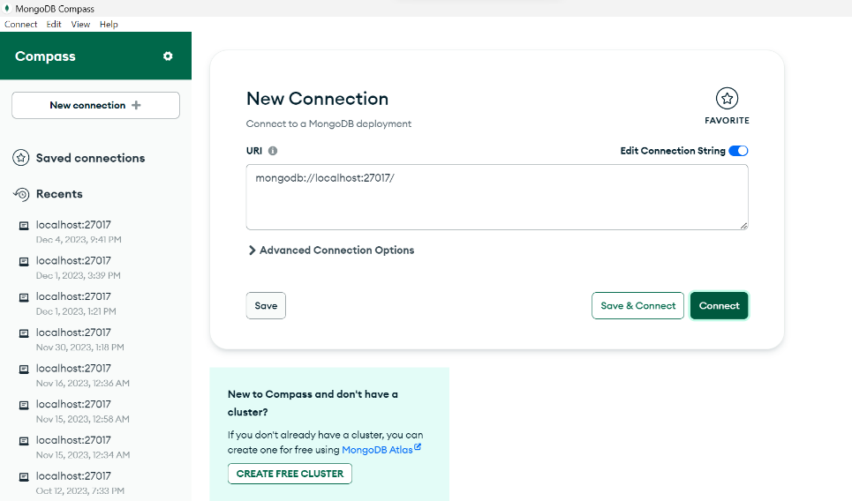

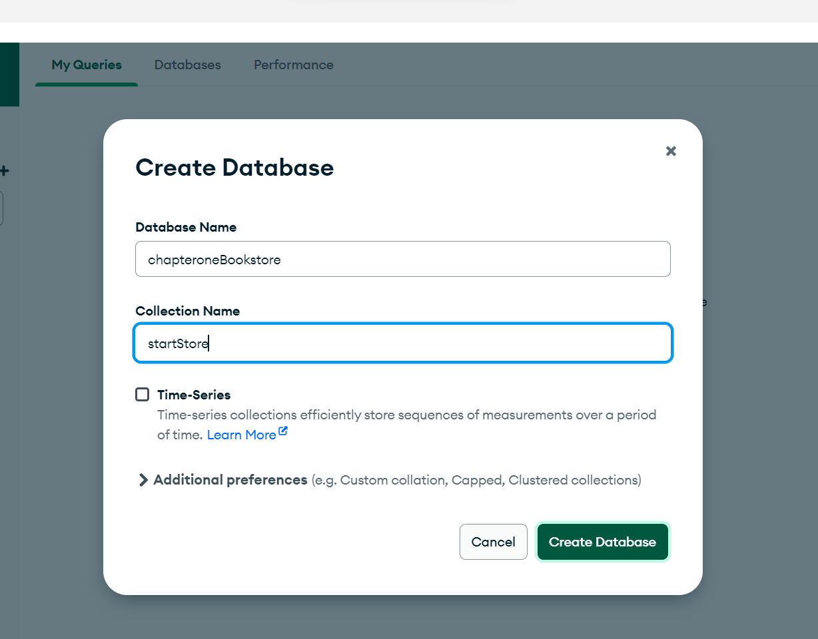

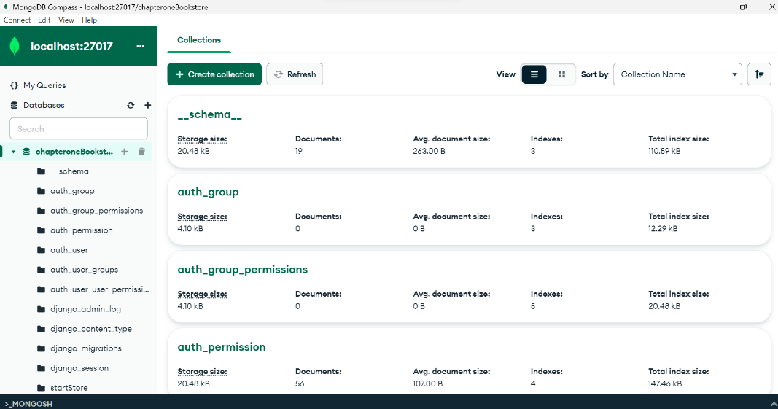

## Templates

**Cart:**cart.html

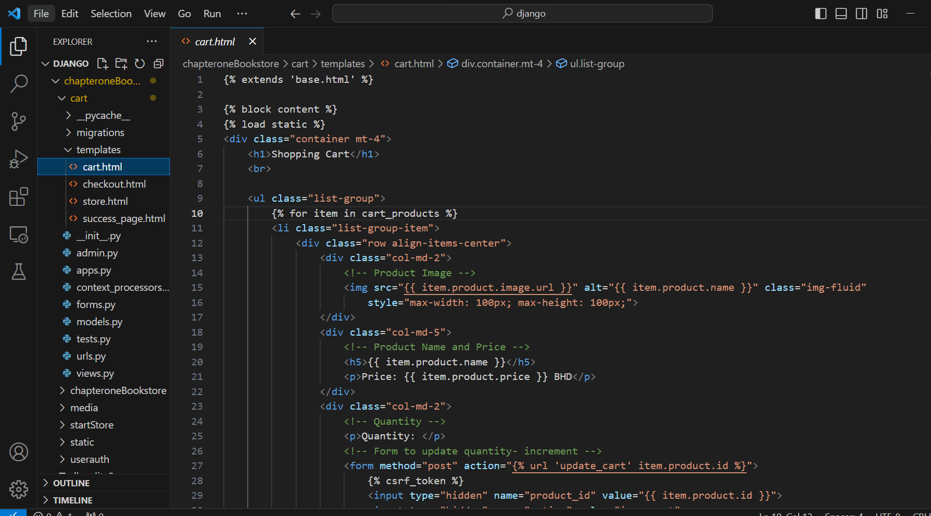

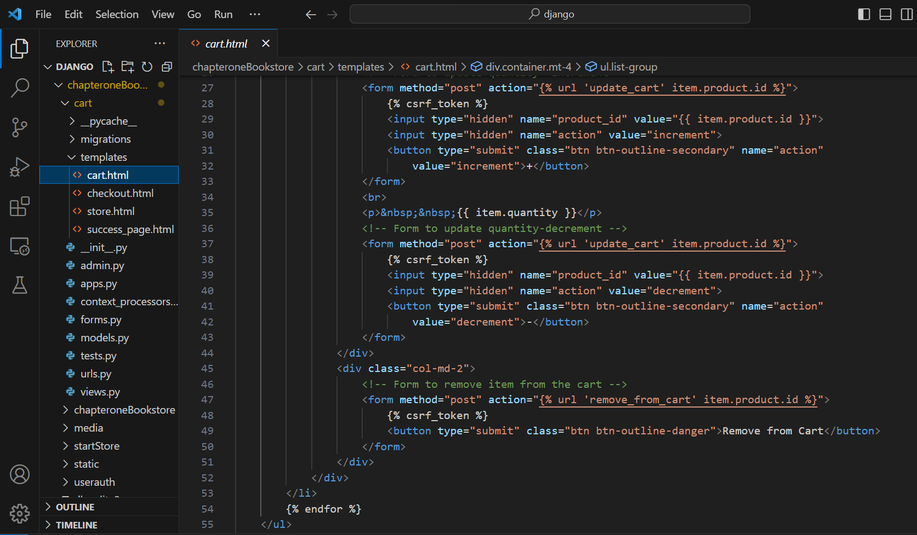

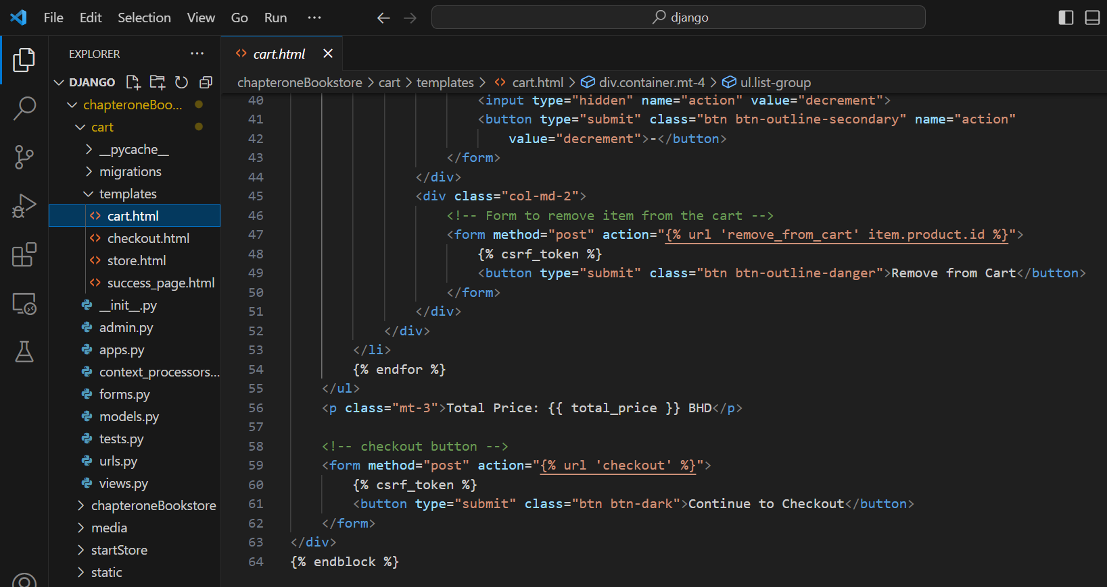

**Cart:**checkout.html

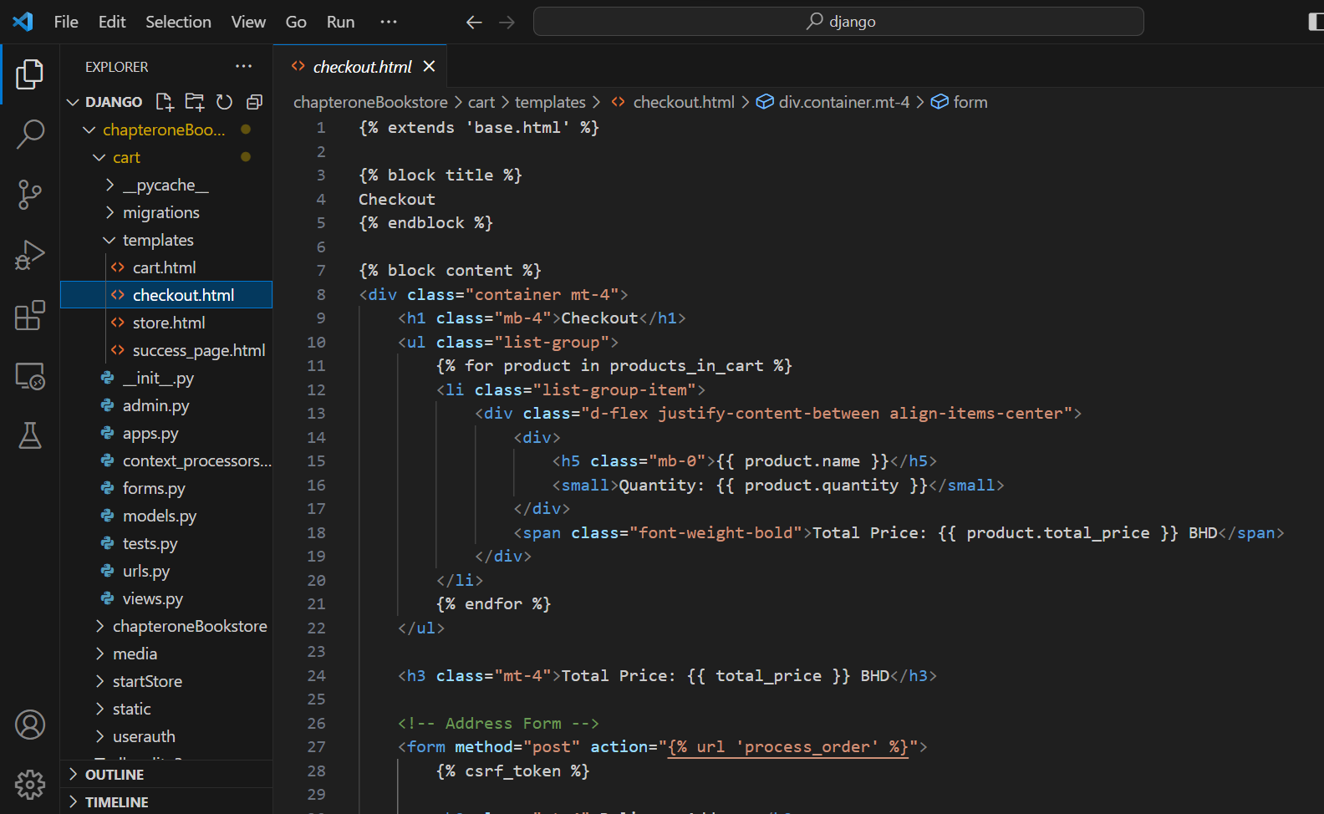

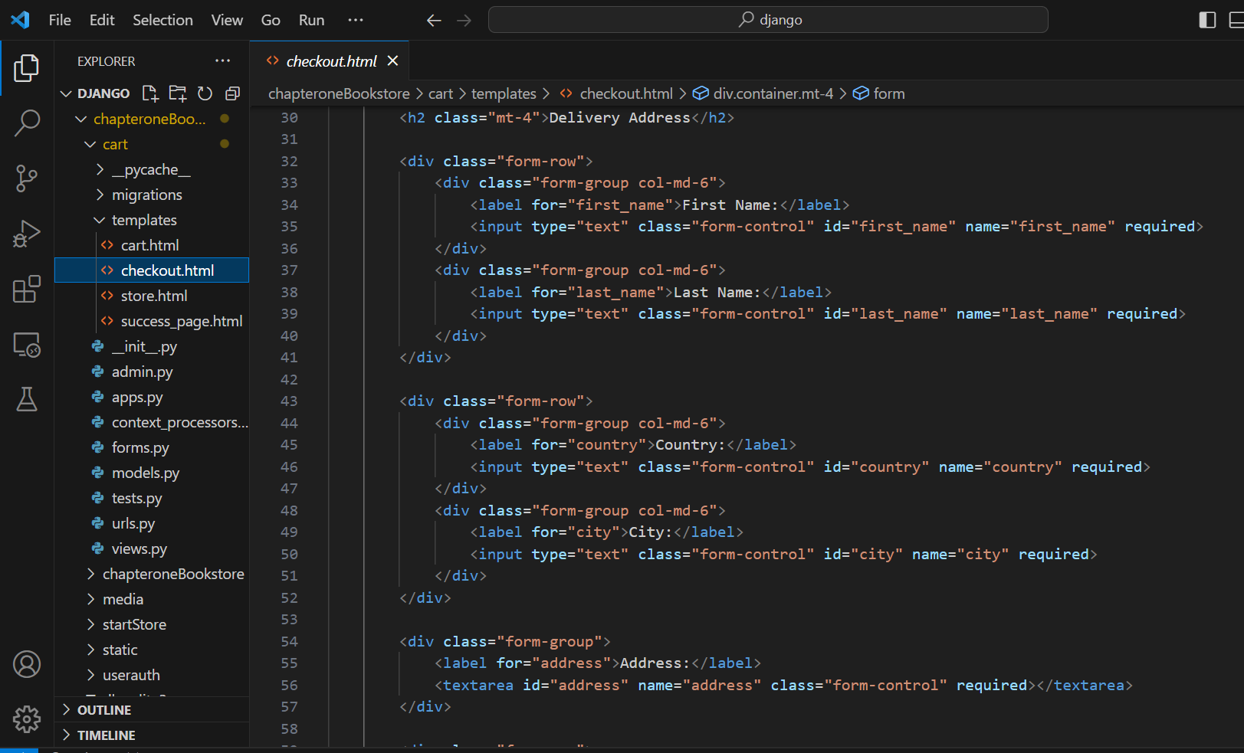

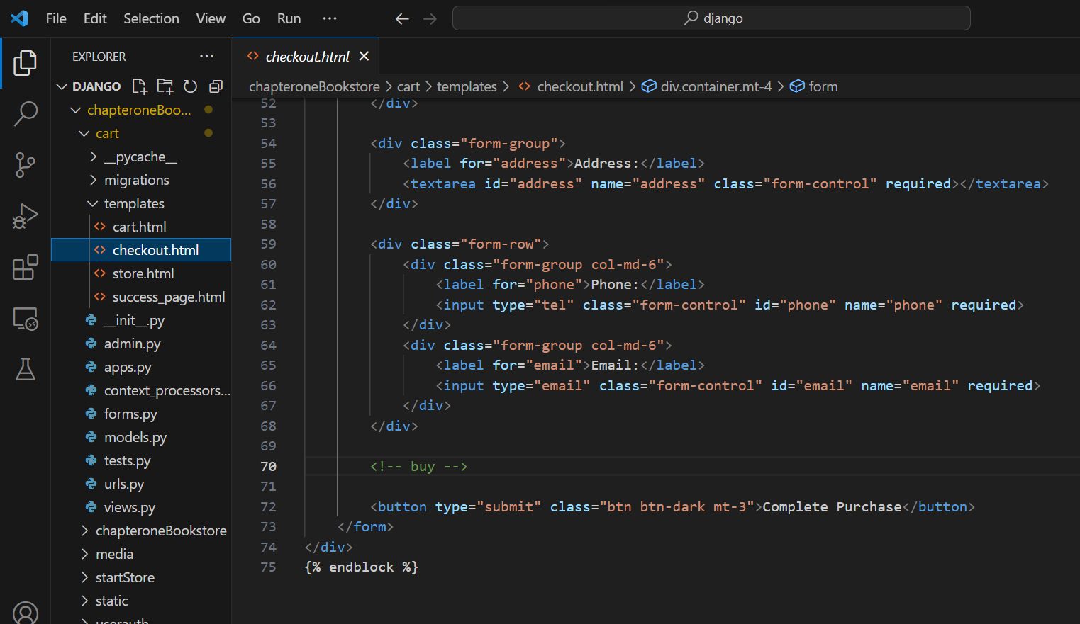

**Cart:**store.html

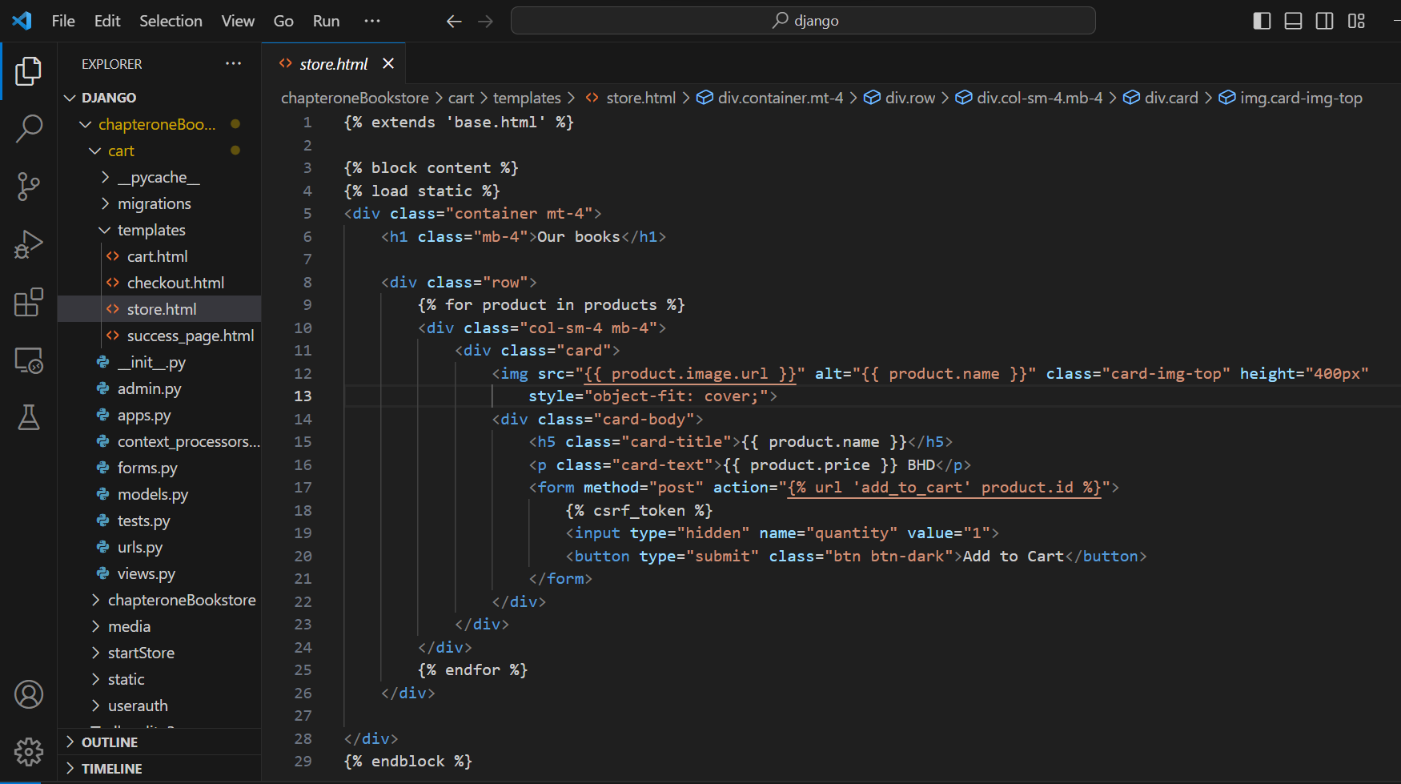

**Cart:** success_page.html

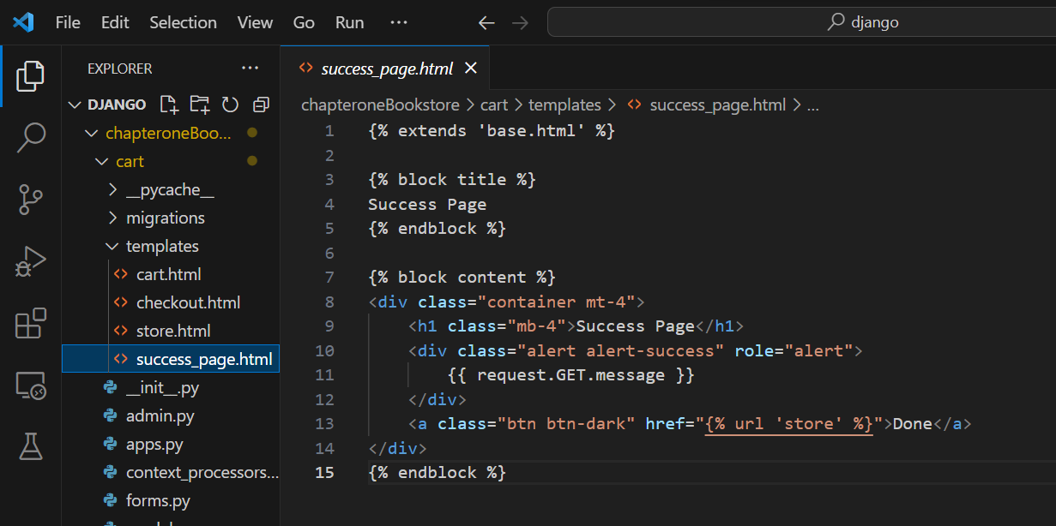

**startStore:** add_sell_books.html

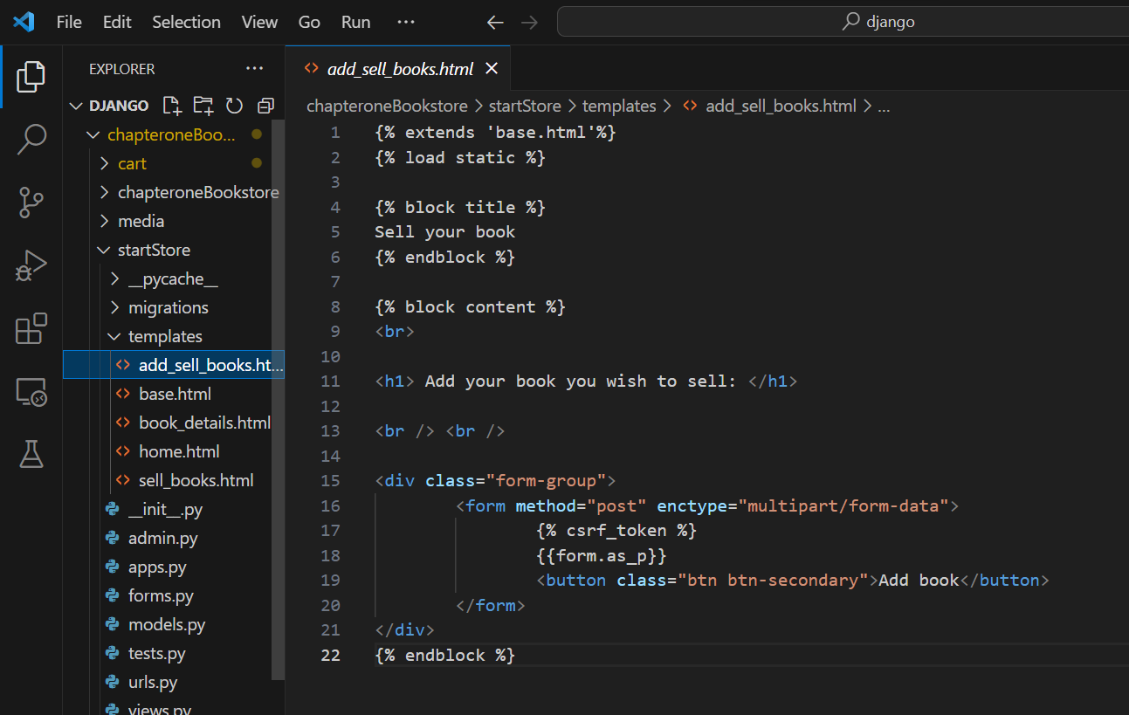

**startStore:** base.html

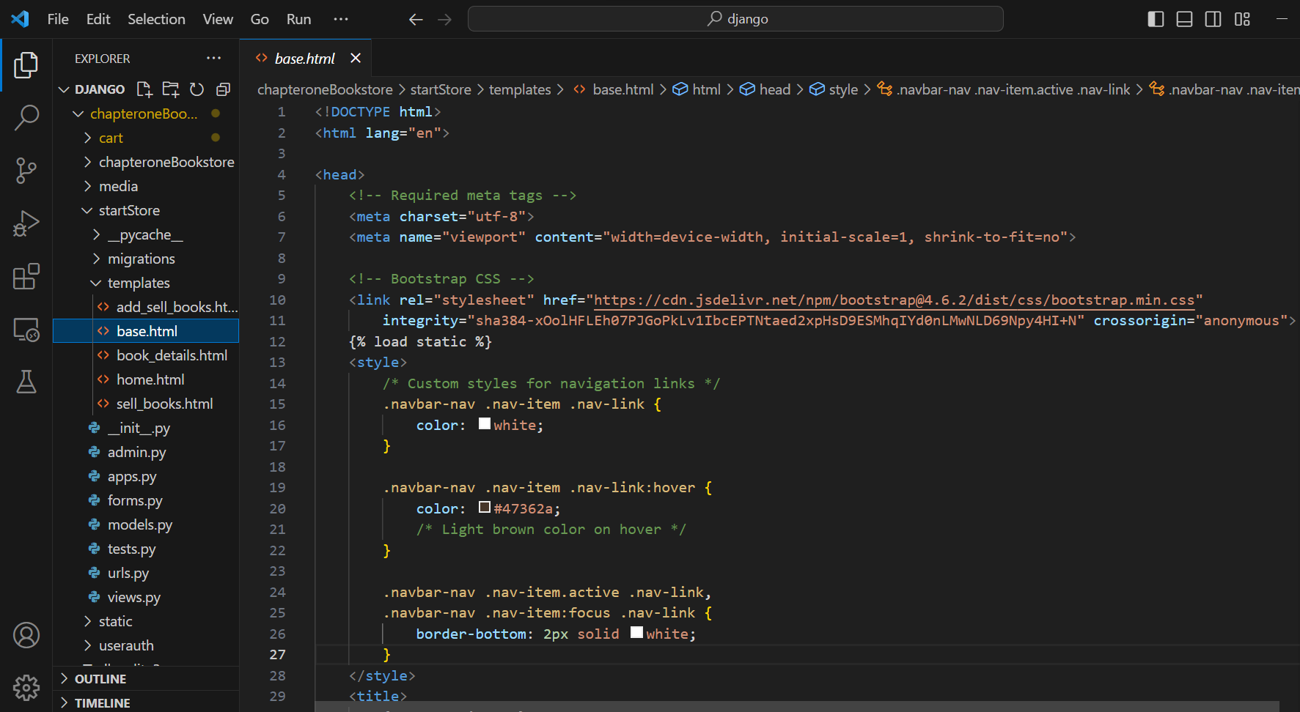

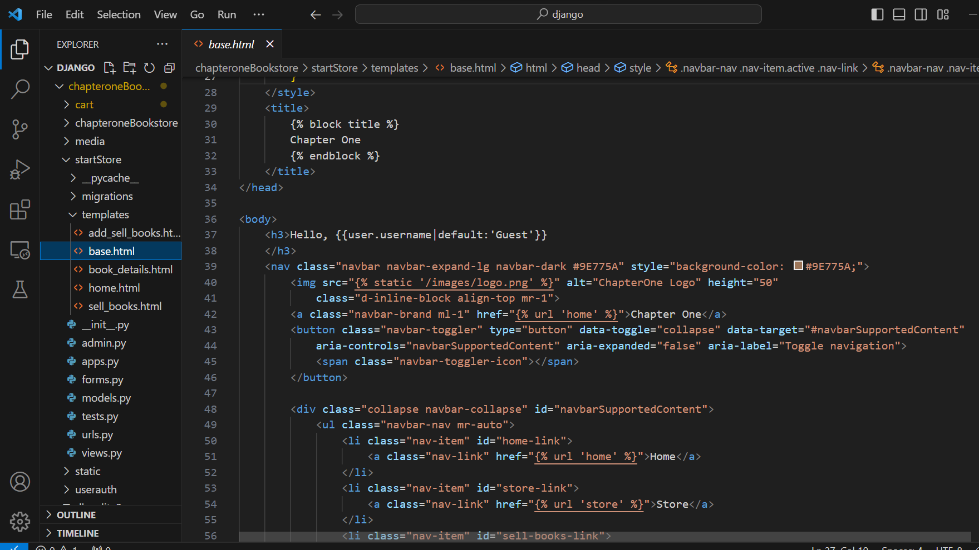

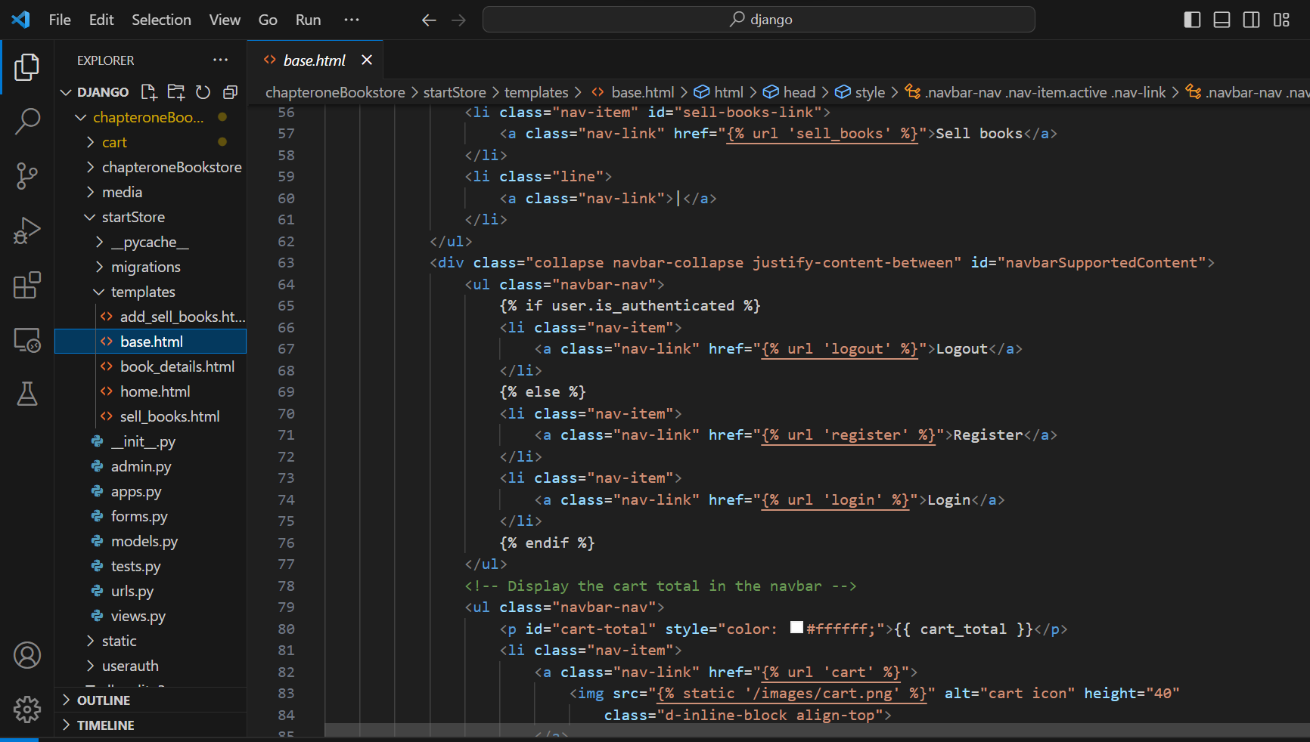

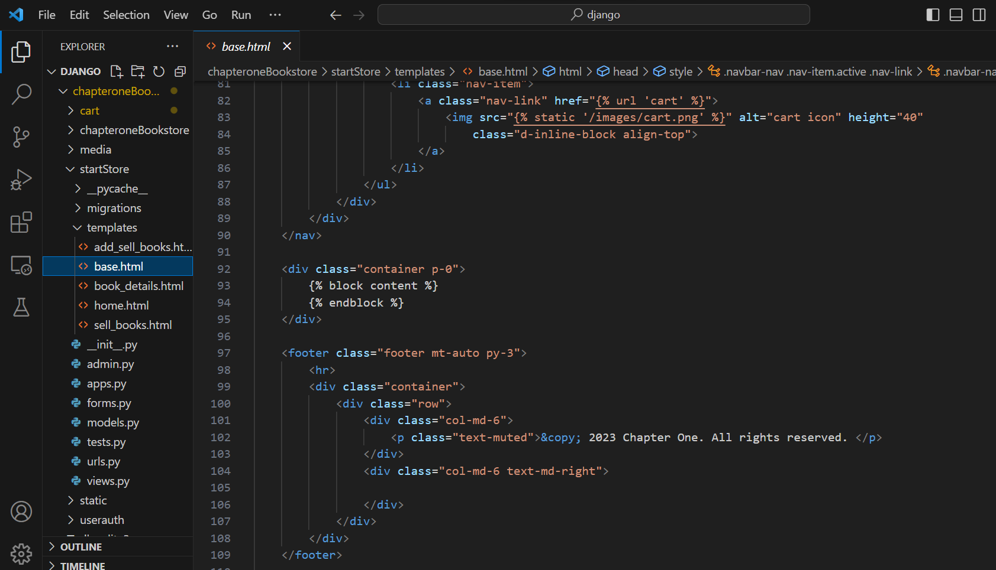

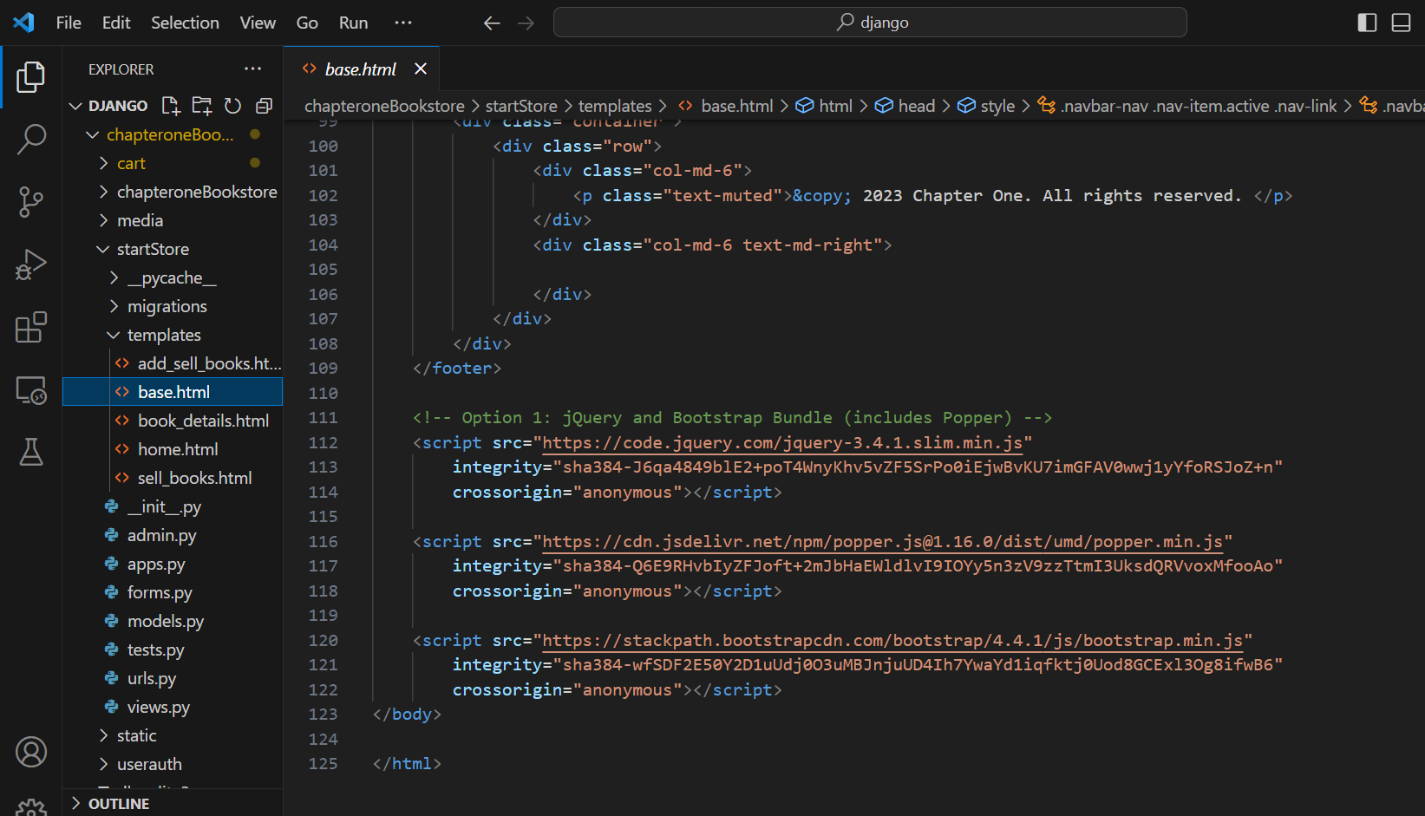

**startStore:** book_details.html

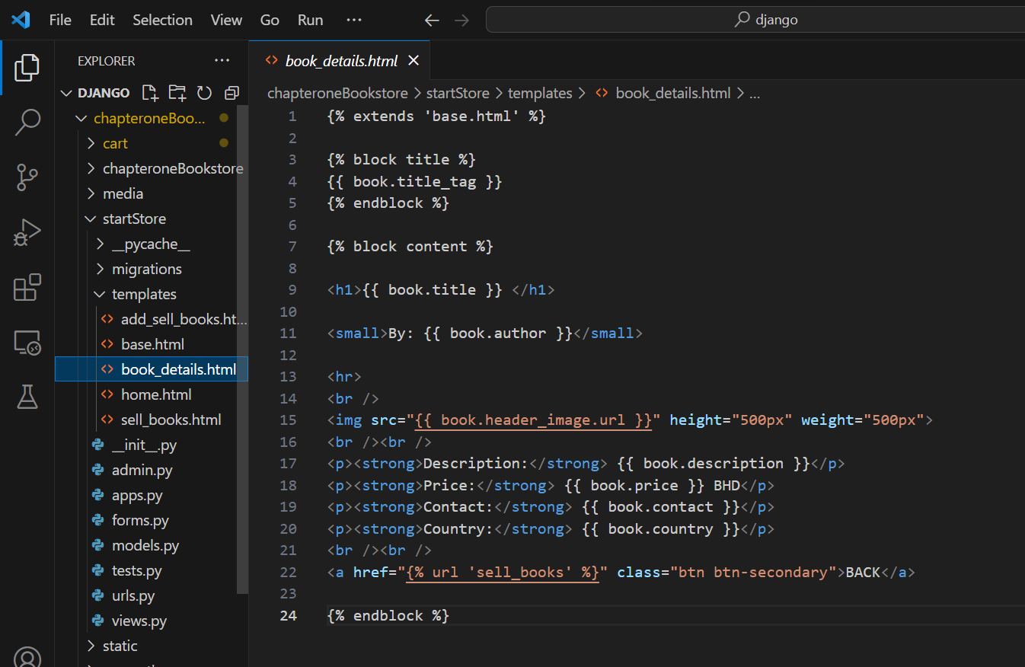

**startStore:** home.html

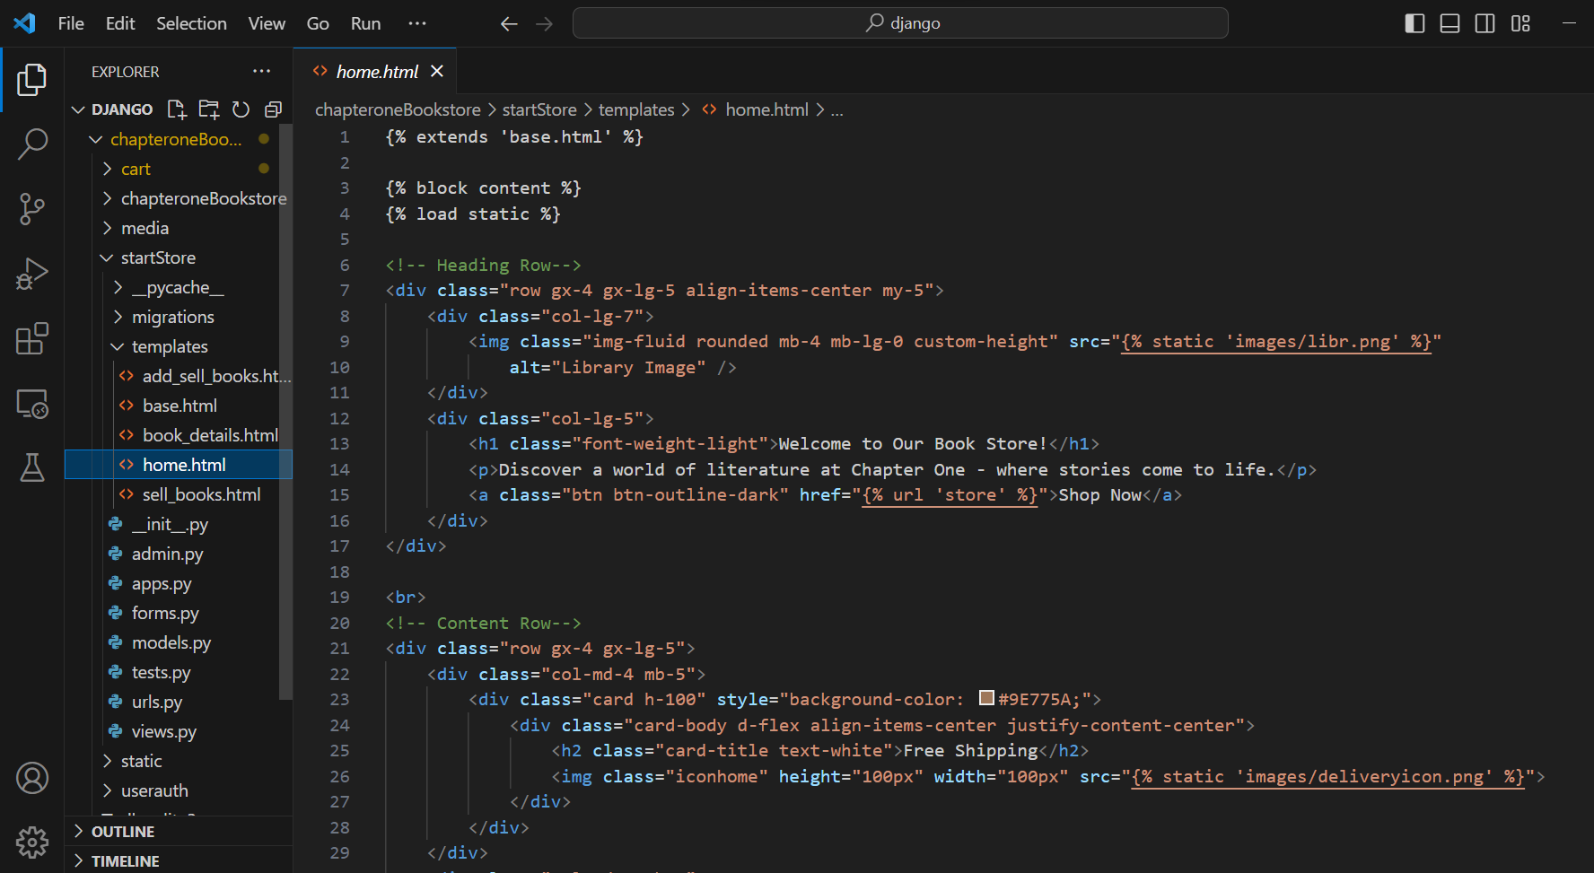

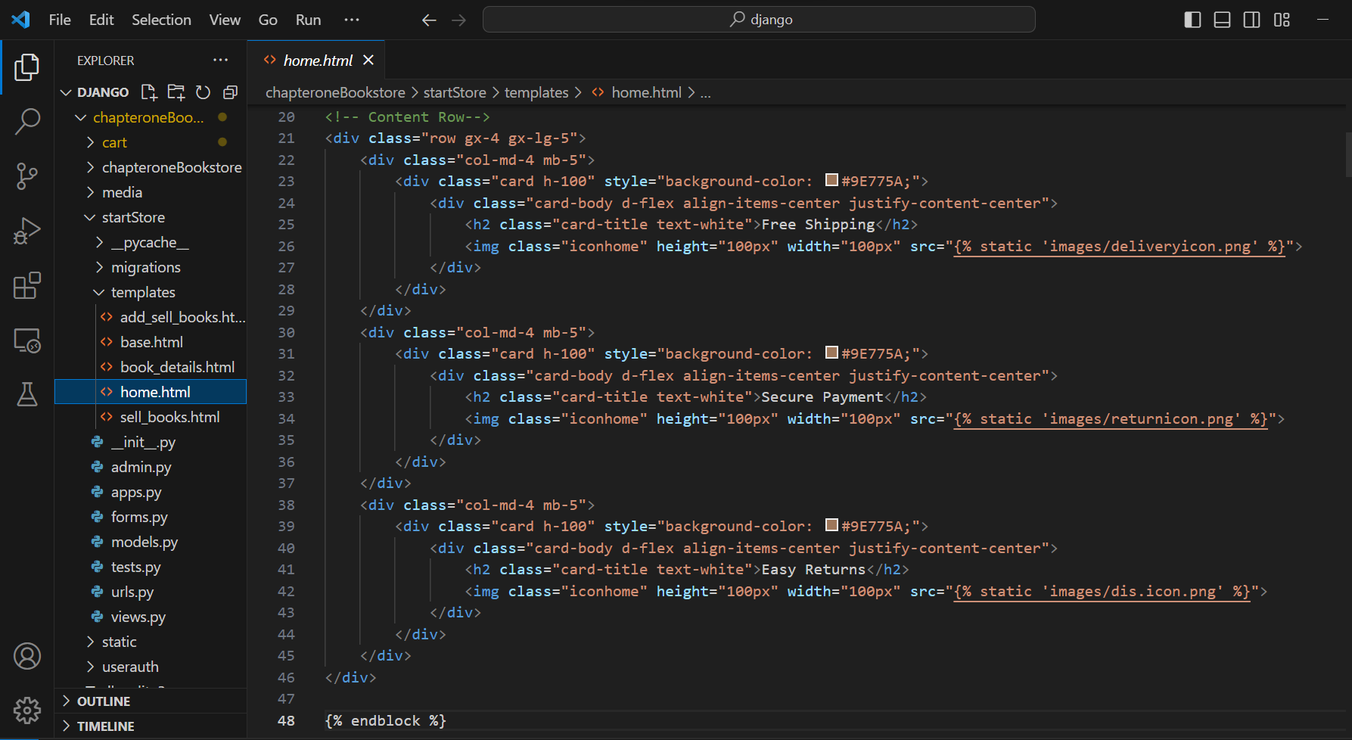

**startStore:** sell_books.html

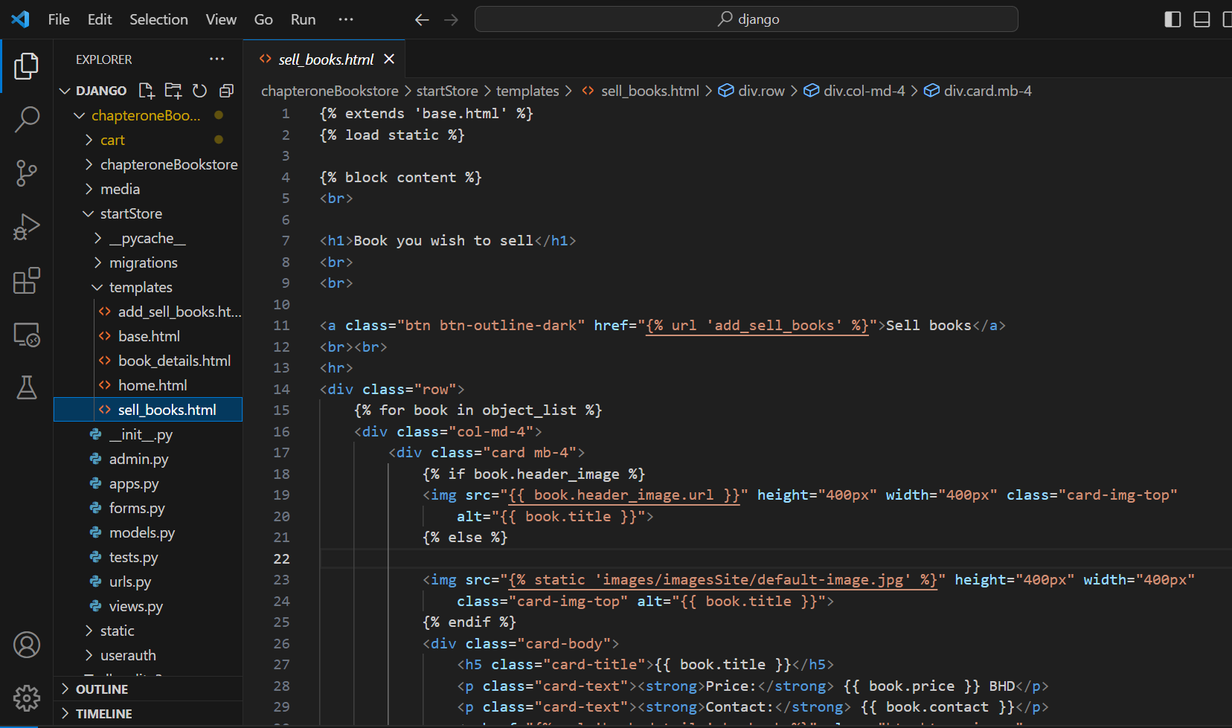

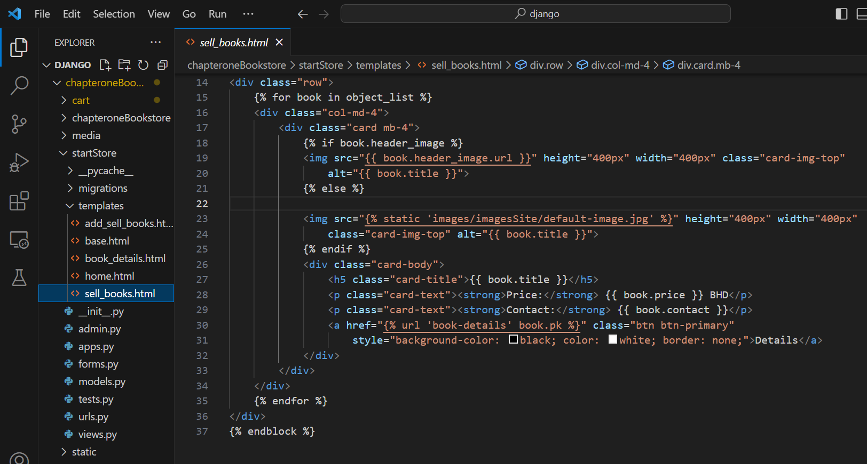

**userauth:** login.html

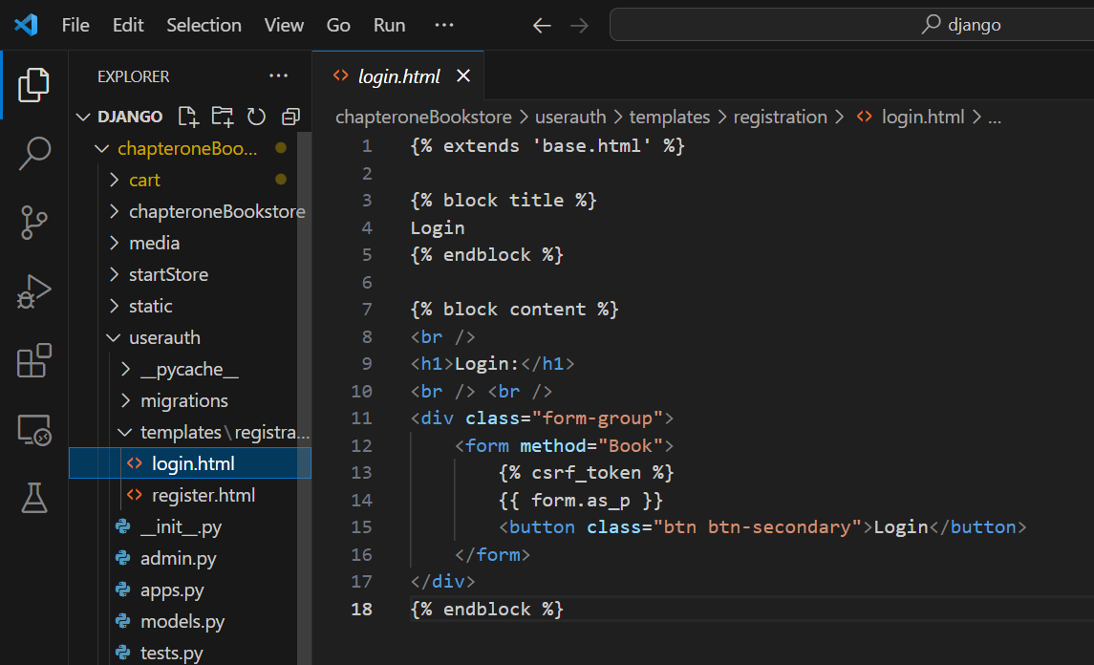

**userauth:** register.html

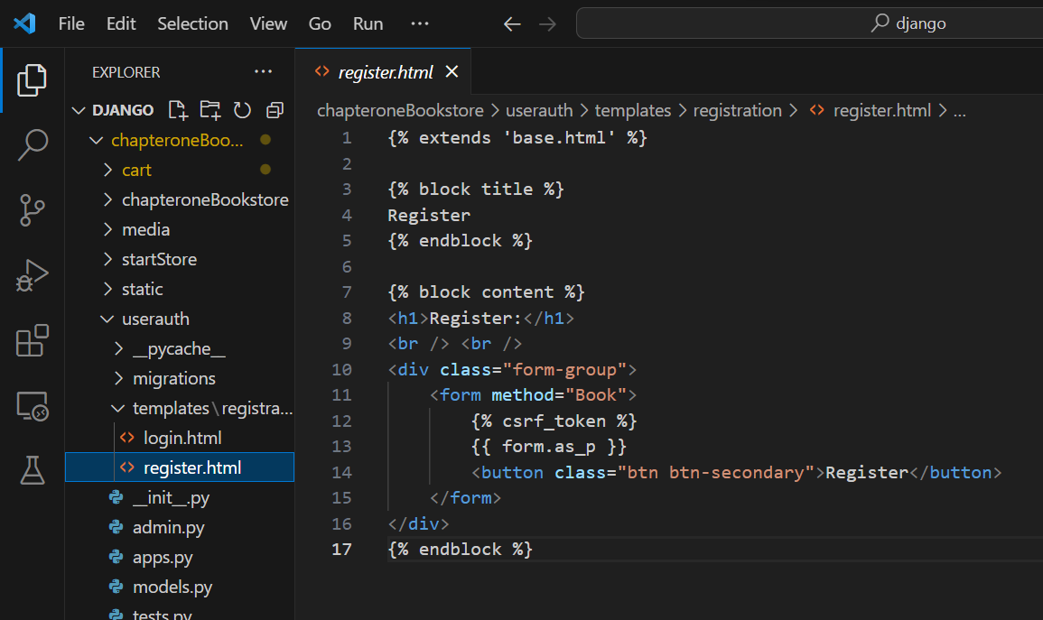

## Model Template

**Cart:**model.py

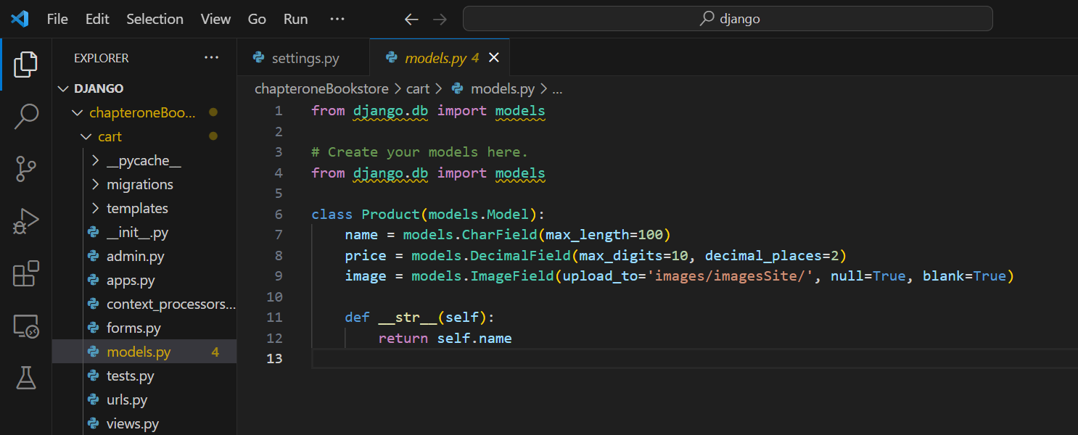

**StartStore:**model.py

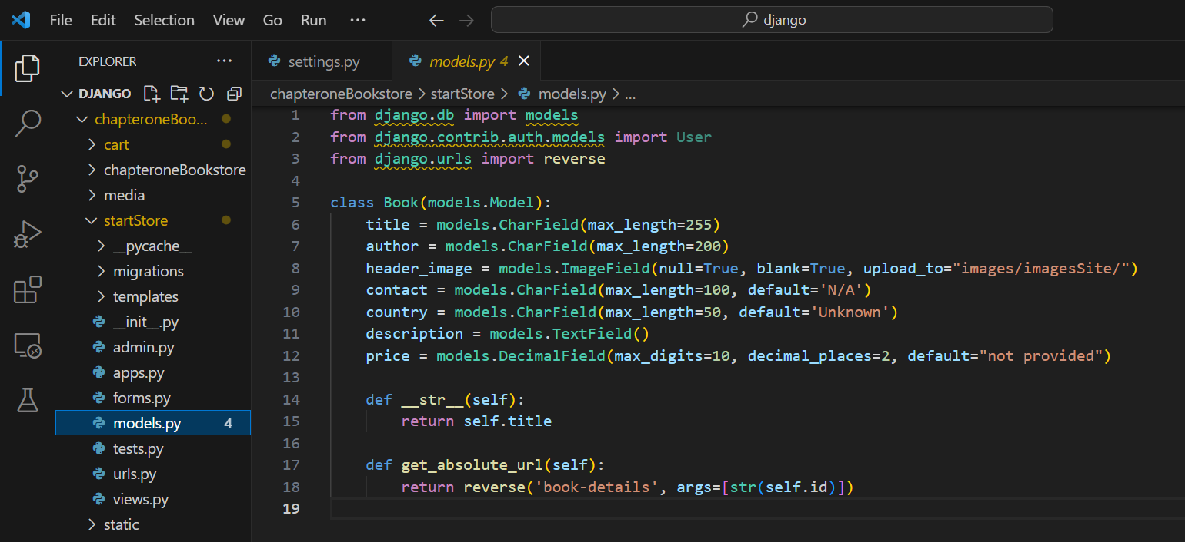

**userauth:**model.py

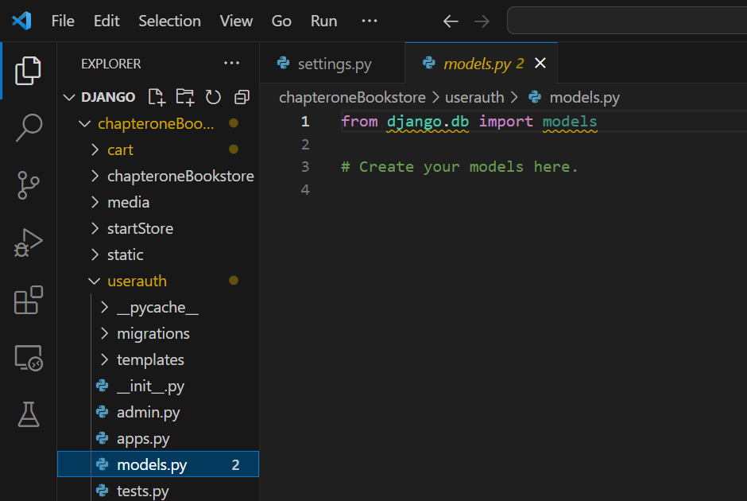

## View Template

**cart:**views.py

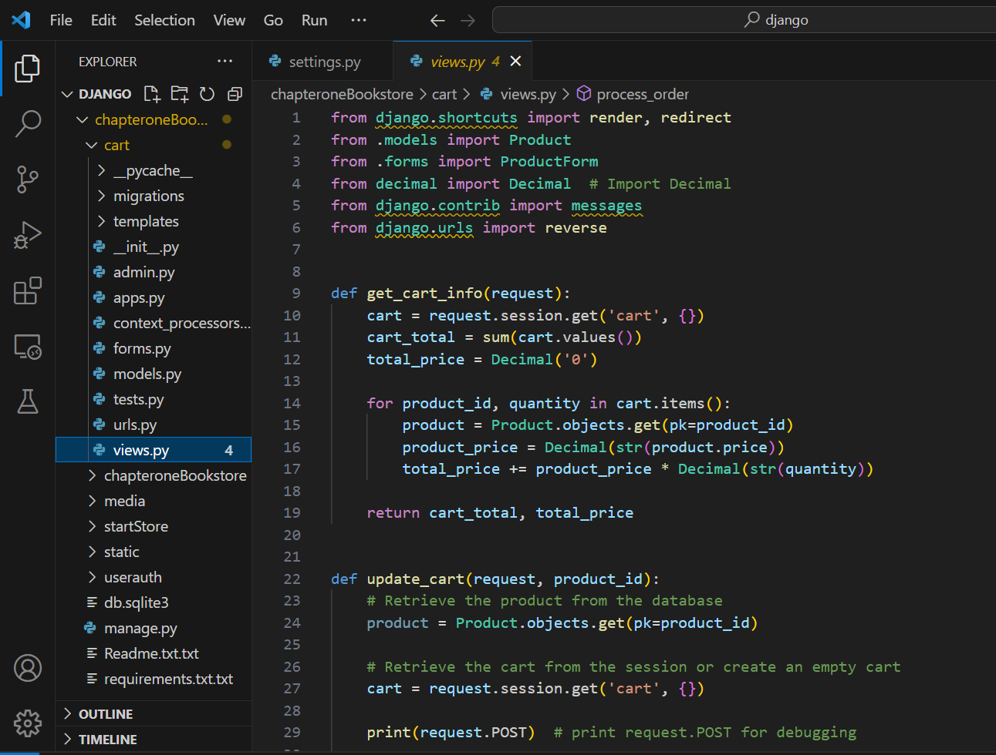

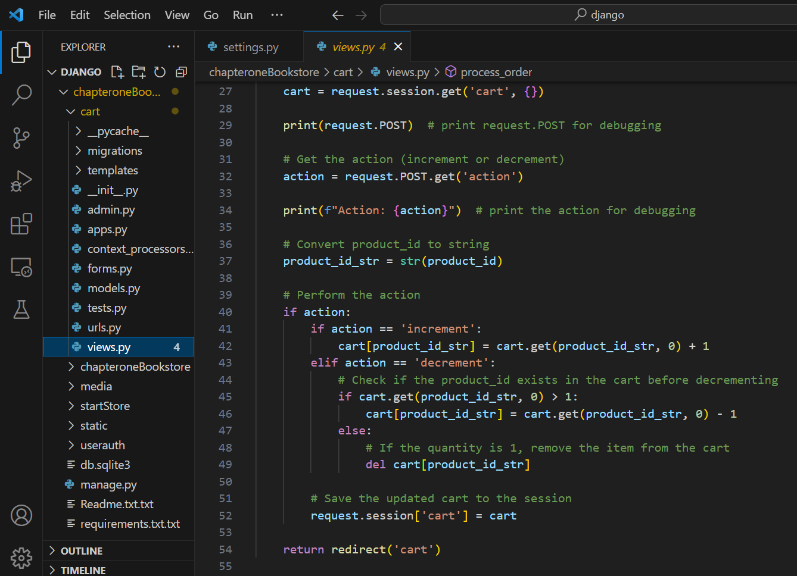

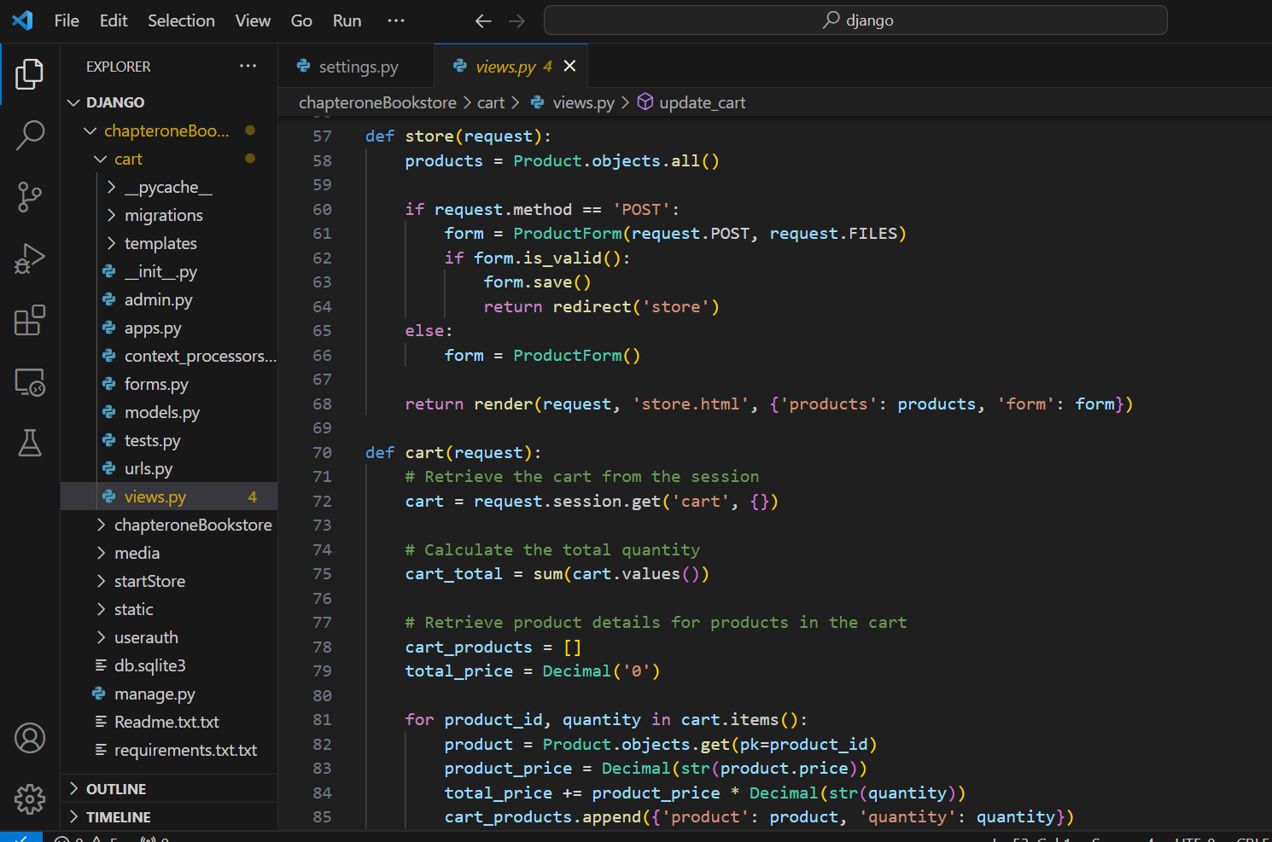

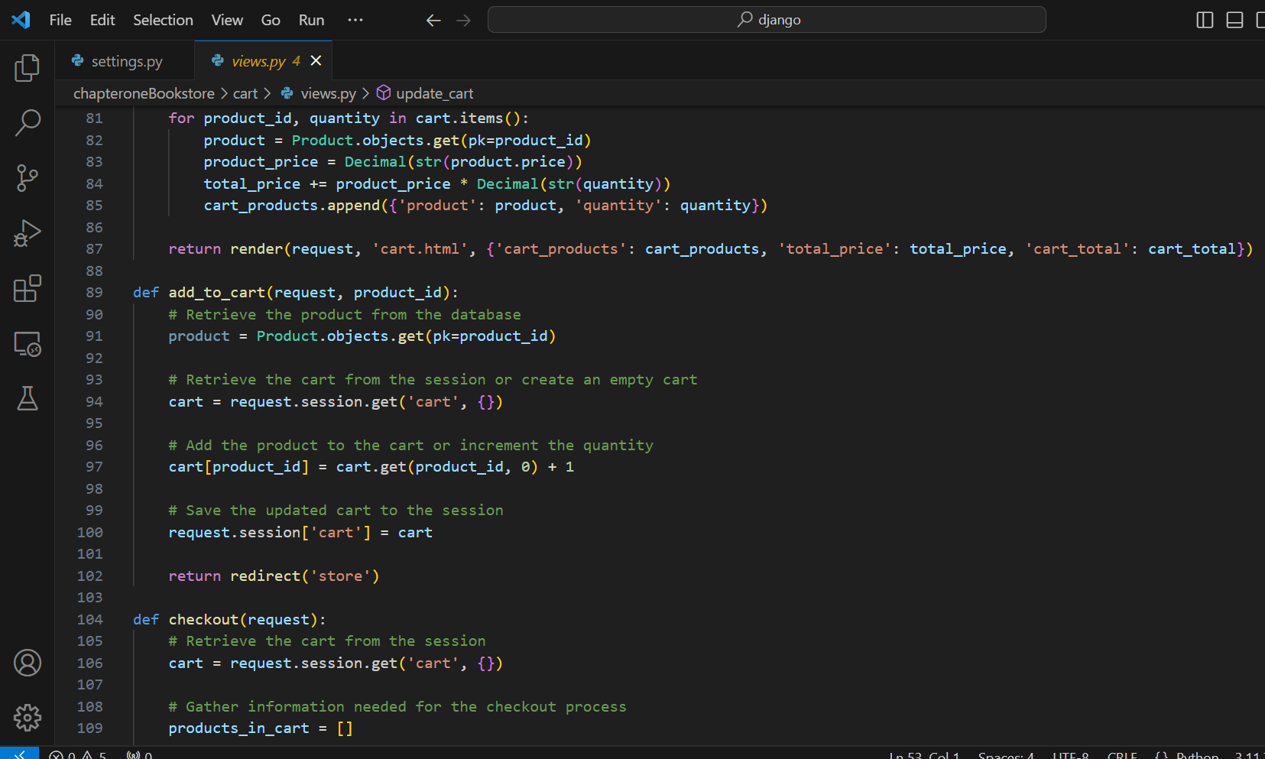

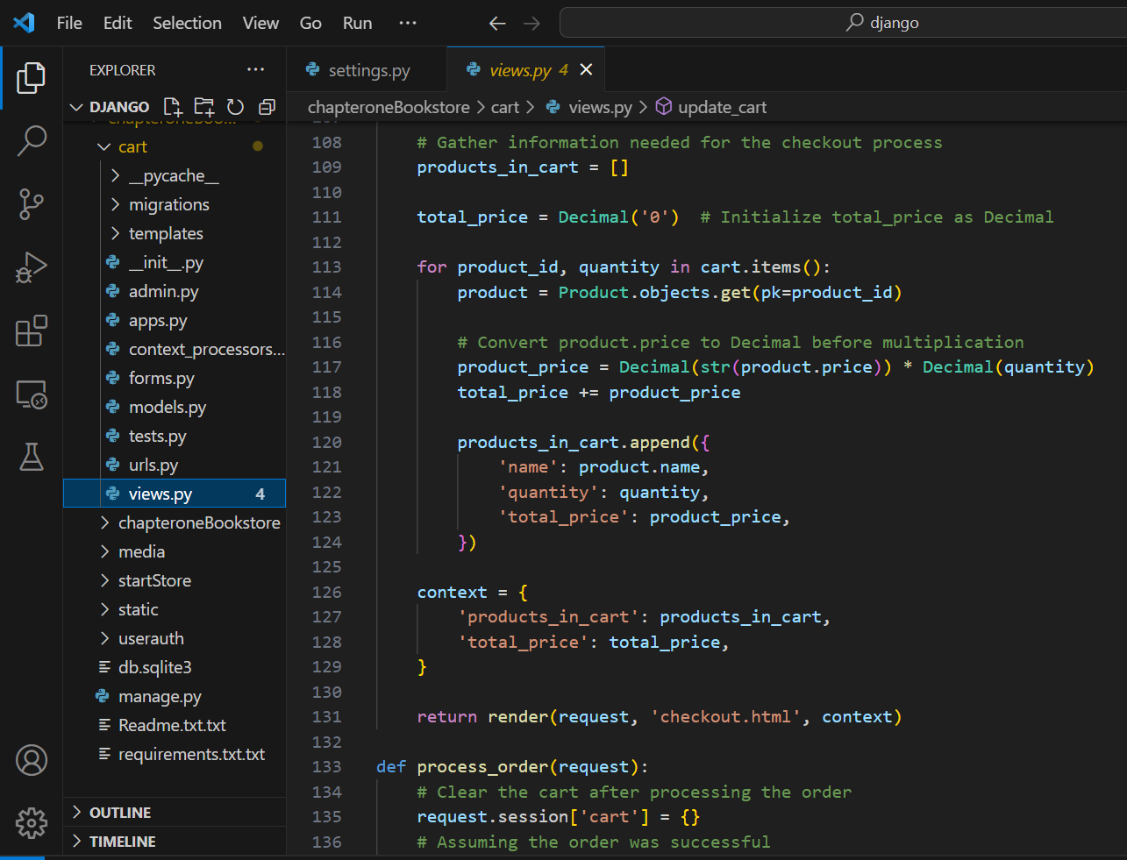

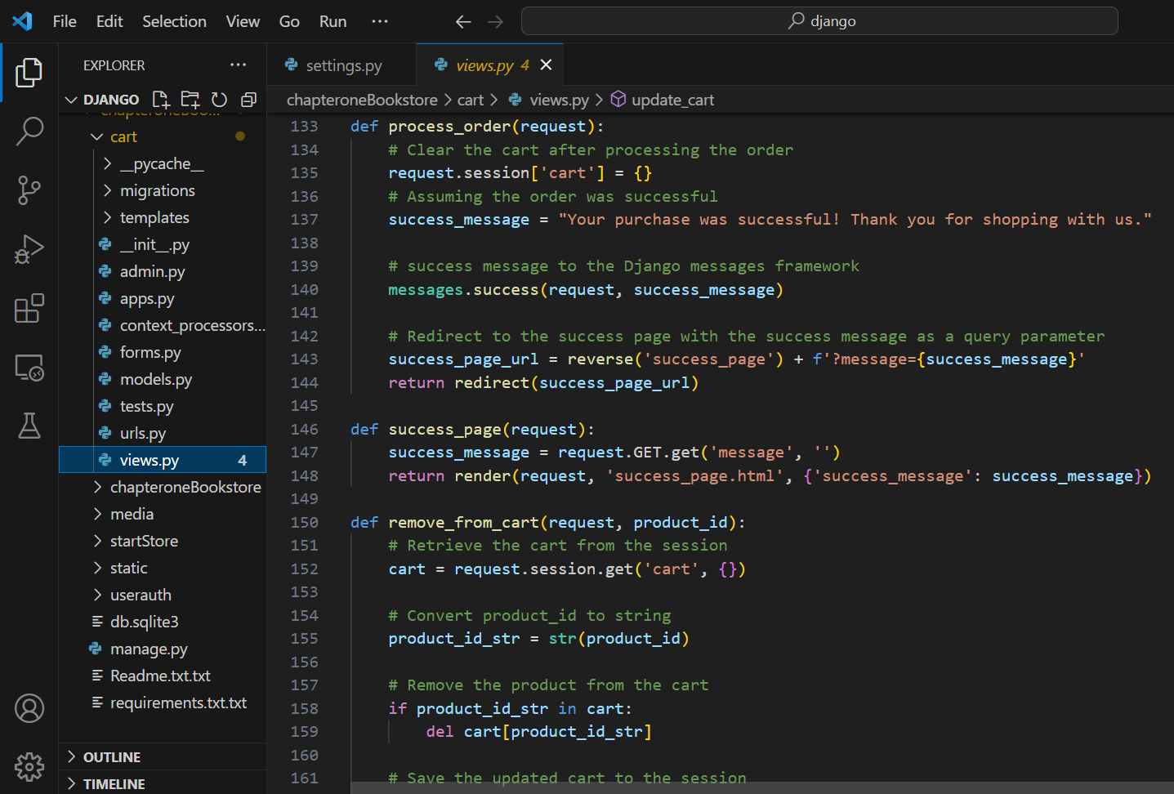

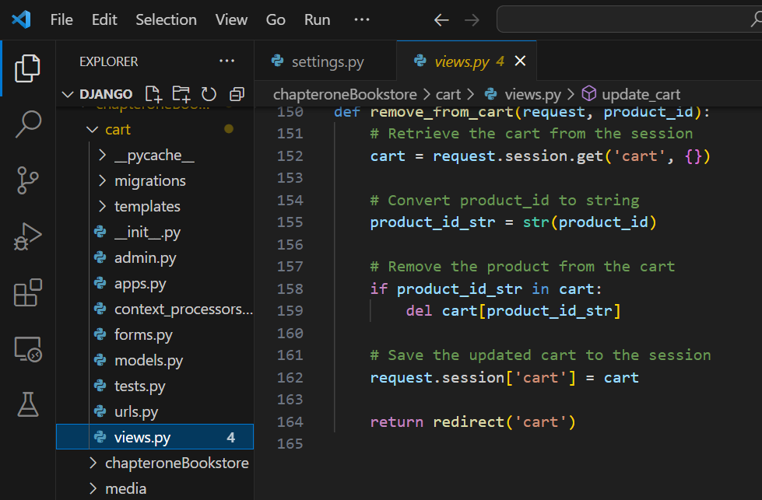

**startStore:**views.py

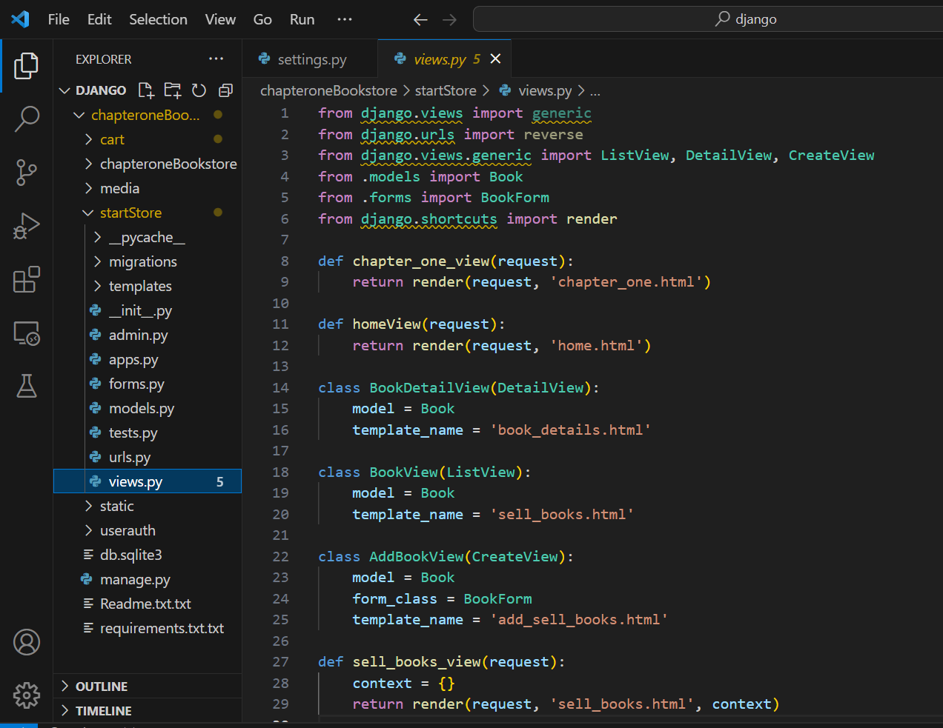

**userauth:**views.py

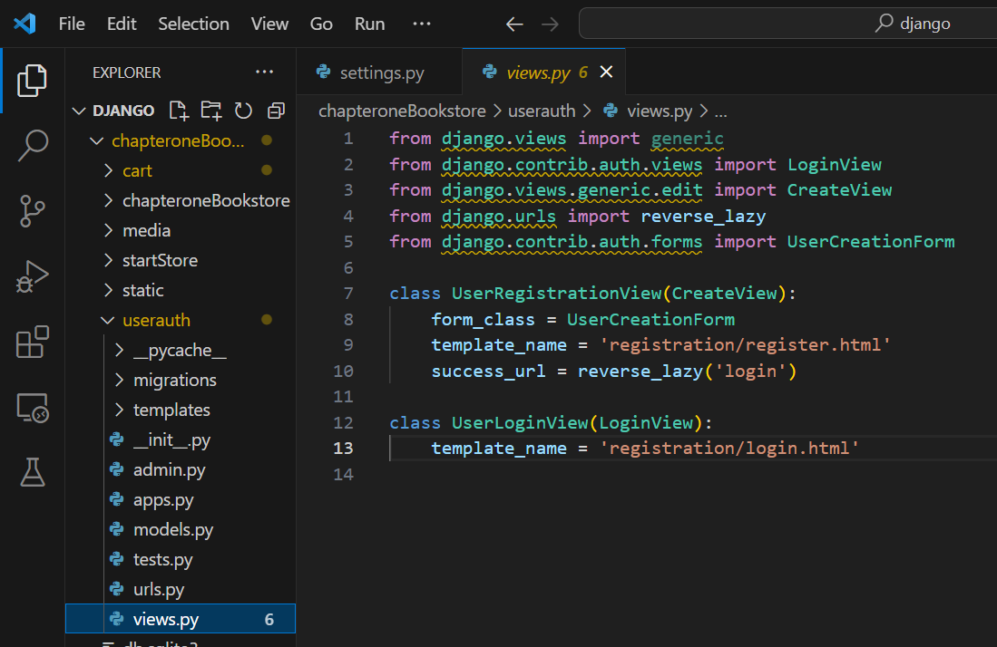

## Django Admin site

**cart:**admin.py

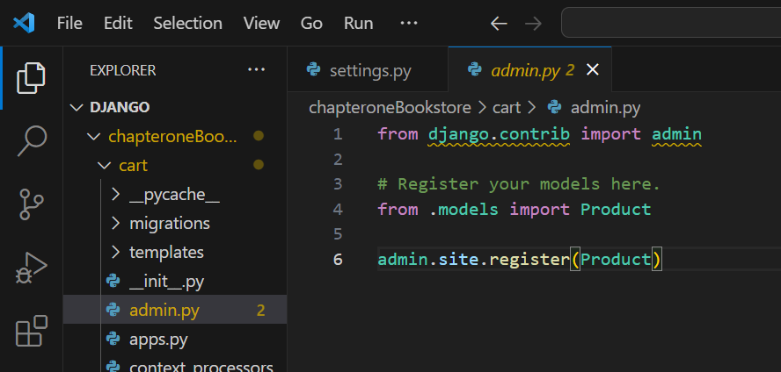

**startStore:**admin.py

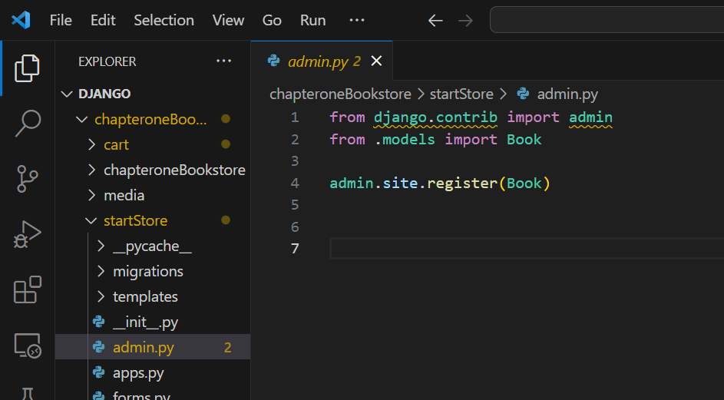

**userauth:**admin.py

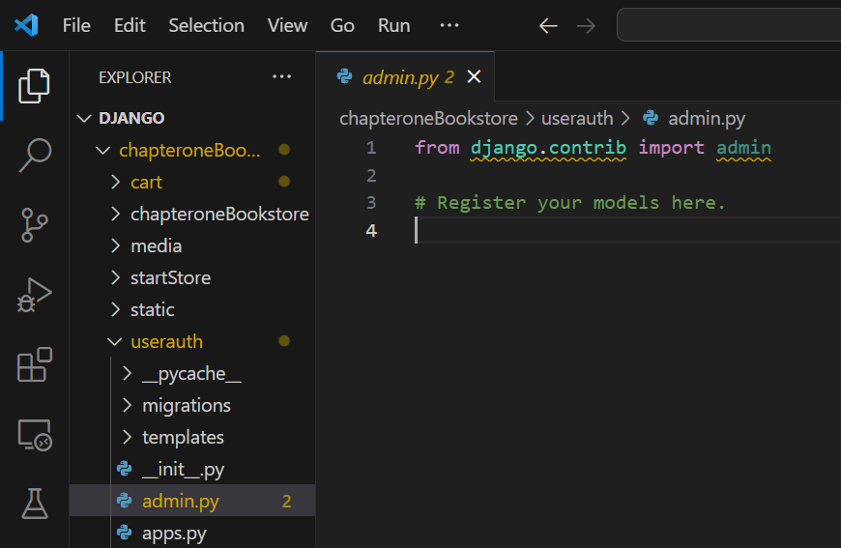

## Django forms

**chapteroneBookstore:** urls.py

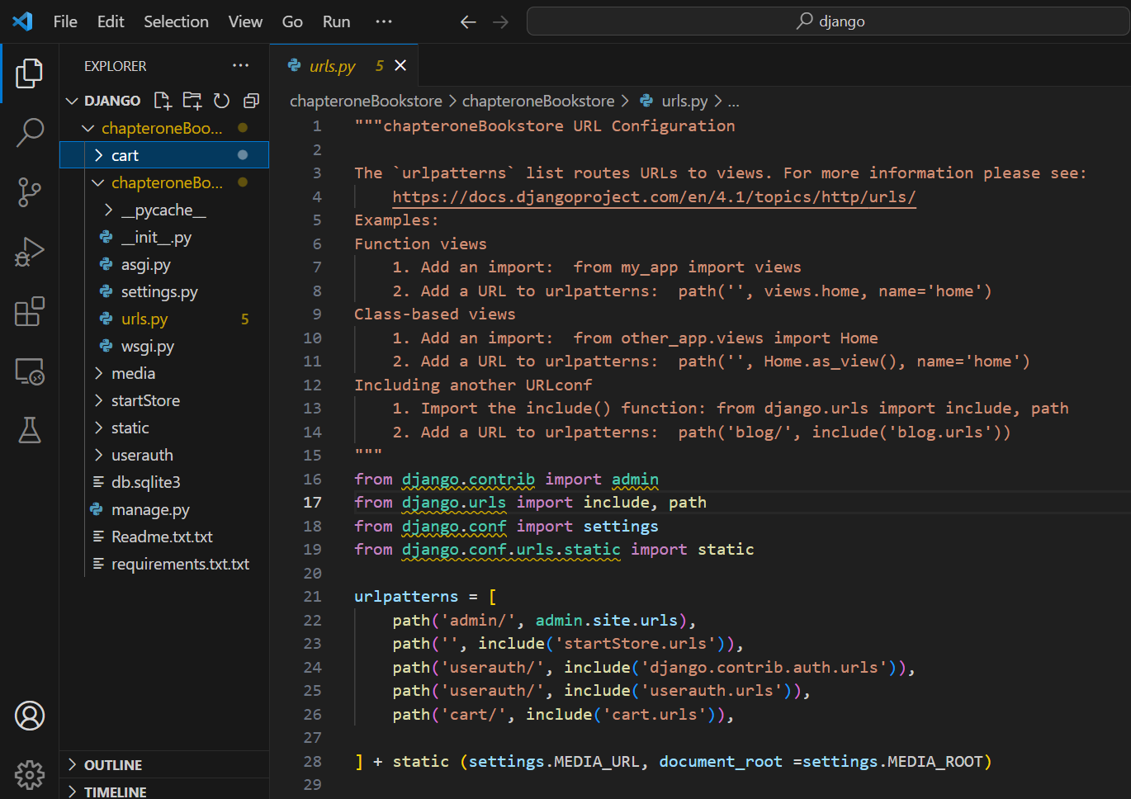

cart :

context_processors.py

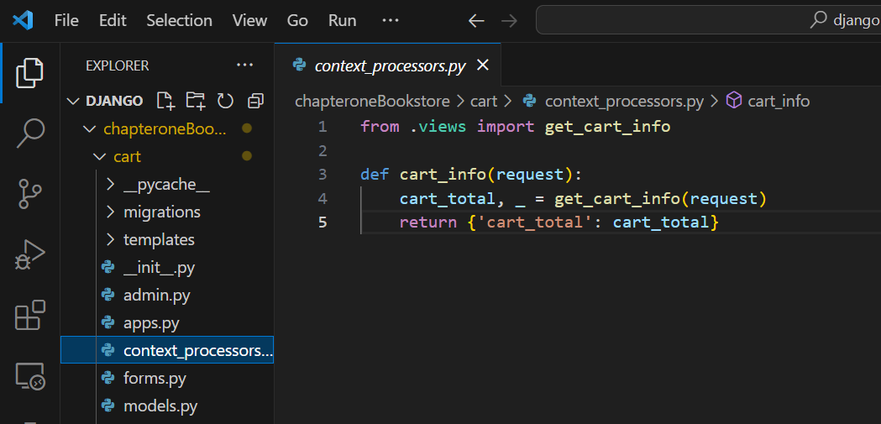

Forms.py 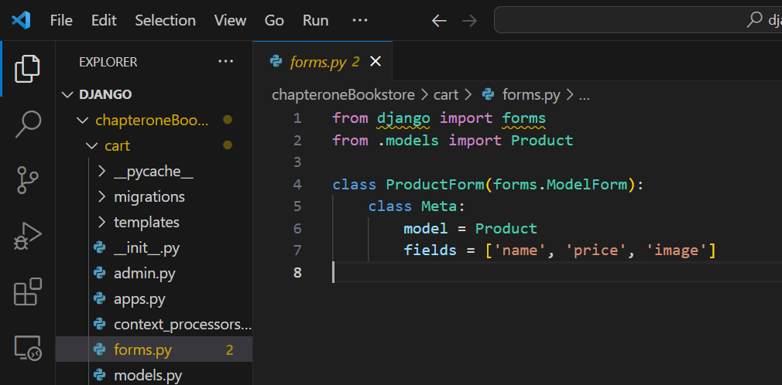

Urls.py

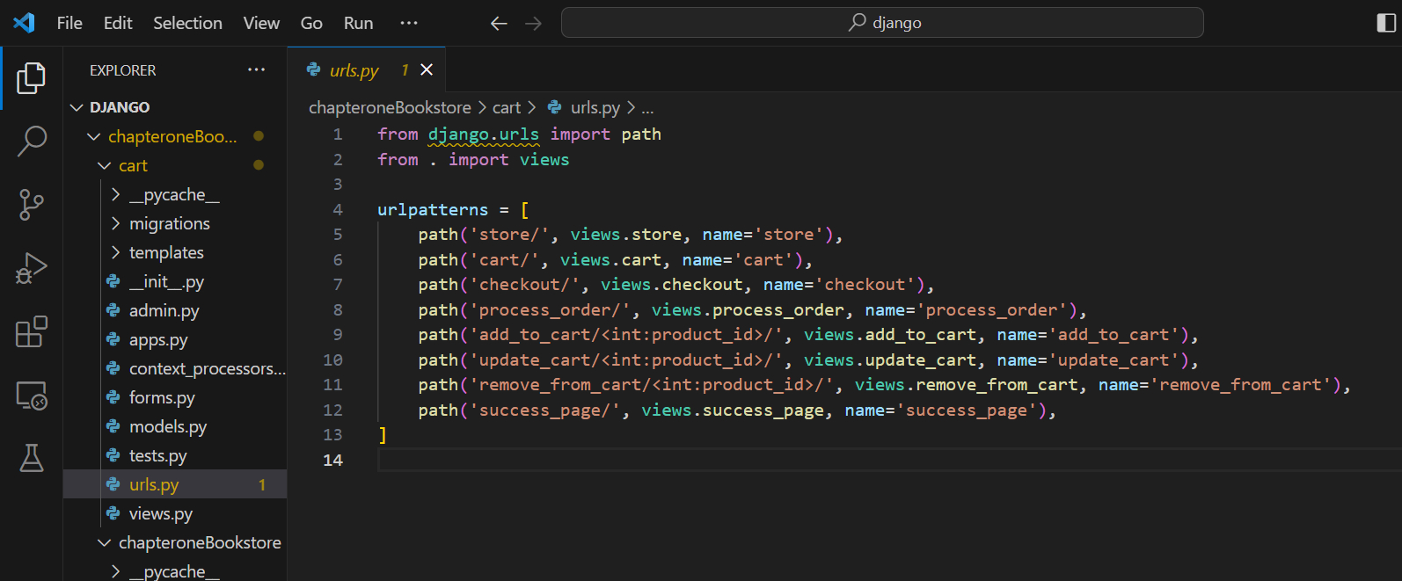

**startStore :**

forms.py

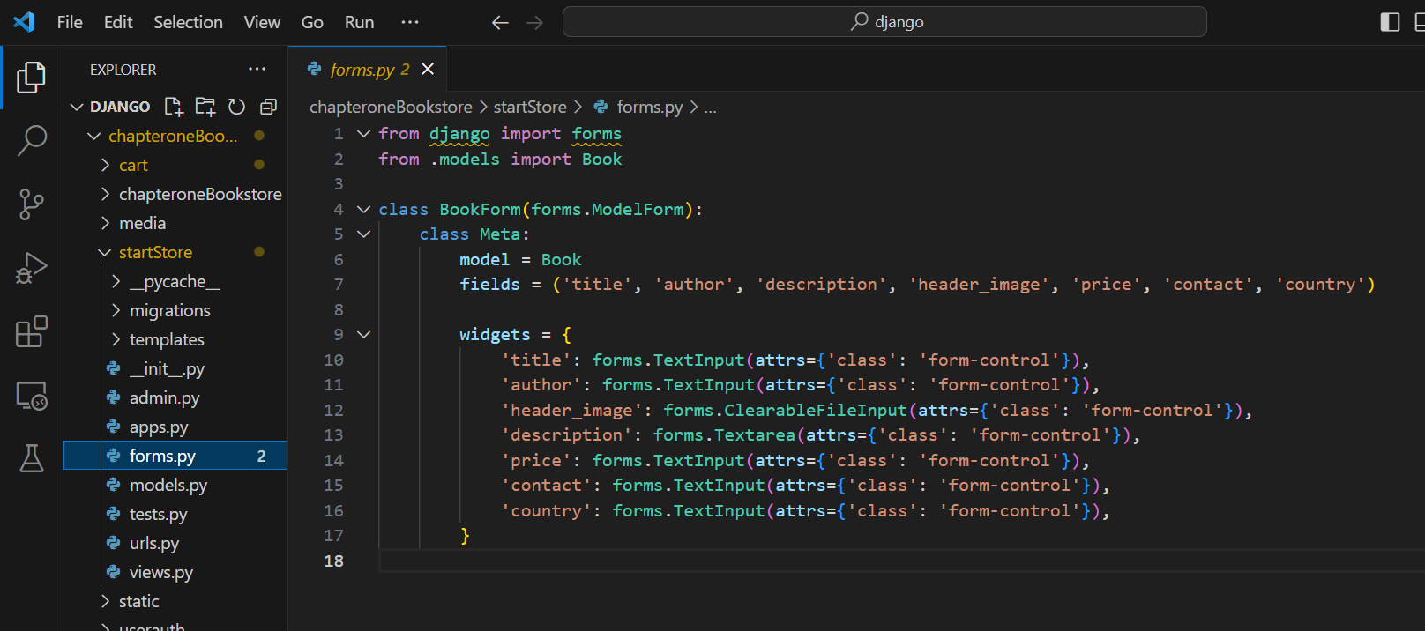

Urls.py

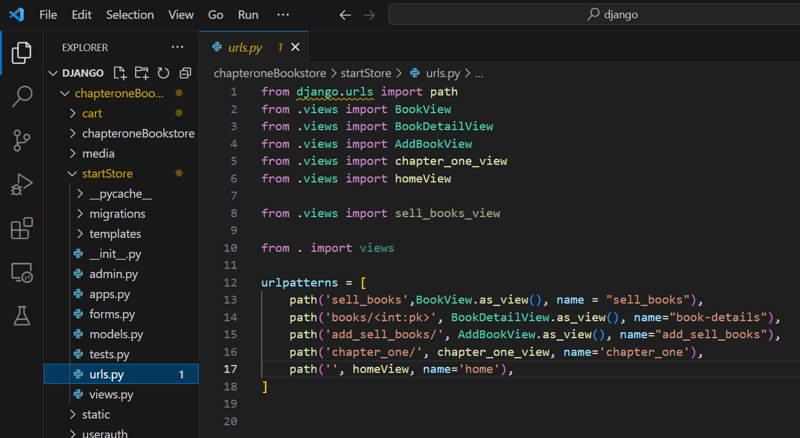

**Userauth:**

Urls.py

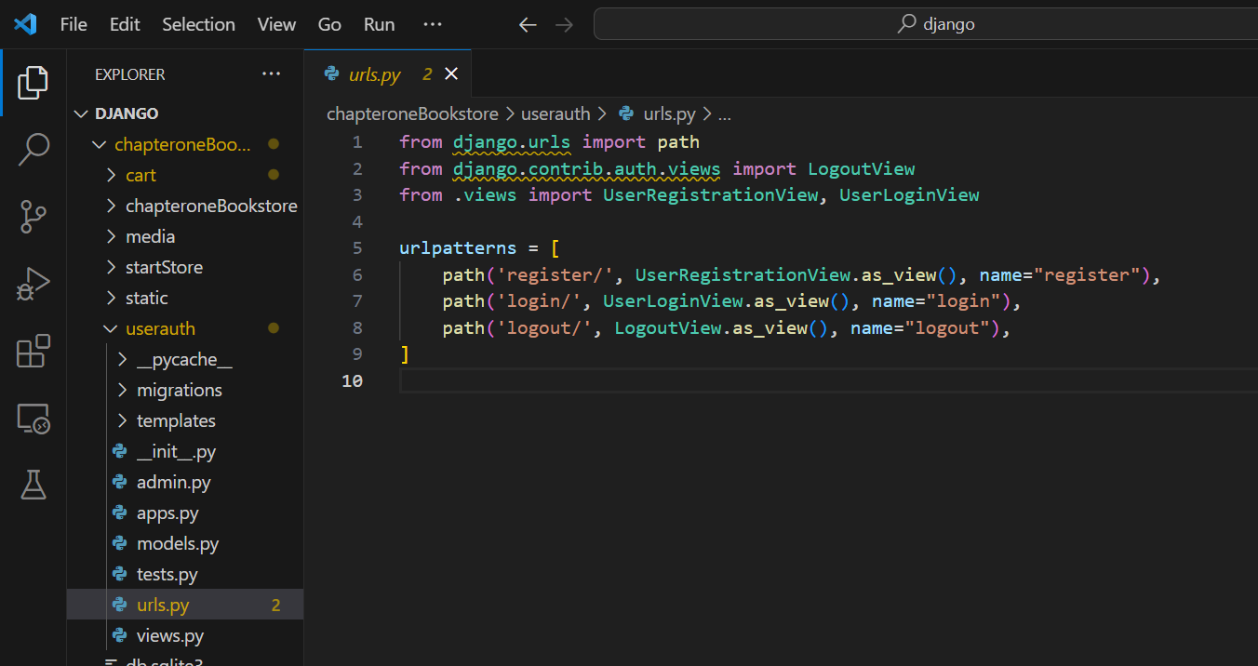

## Incorporation of Bootstrap

Cart.html

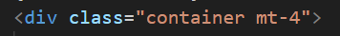

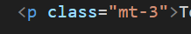

The mt-4 class adds margin-top to the container.

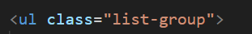



styles for headings (h1) and list groups.







Bootstrap's grid system for creating a responsive layout with columns.







used for styling buttons, for example, btn-dark to make button in dark color.

Checkout.html

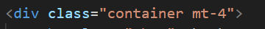

used to contain and center the content, mt-4 class adds margin-top to the container.





mb-4 for margin-bottom and mt-4 for margin-top.



d-flex class is part of Bootstrap's Flex utility classes and justify-content-between and align-items-center are used for flexbox alignment.



form-control class is used to style form controls, providing consistent styling across browsers.

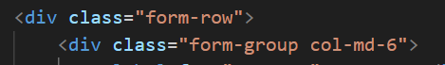

Bootstrap's grid system for layout.

Store.html

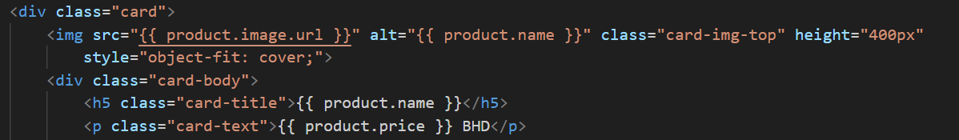

card component with classes like card, card-img-top, card-body, and btn that enhance the visual appearance of the product display and the "Add to Cart" button.

success_page.html

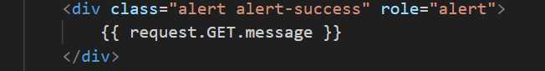

alert component with classes like alert and alert-success used to display a success message.

add_sell_books.html

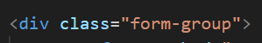

used to group form elements.

base.html



meta tags are used to make the webpage responsive on different devices.



Bootstrap CSS file from a CDN (Content Delivery Network).



navbar class is part of Bootstrap for navigation bar.

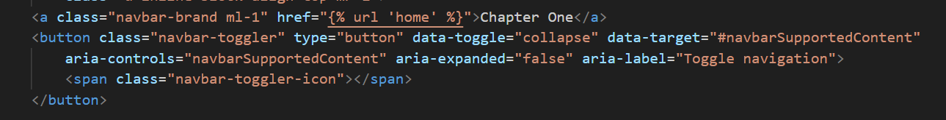

are used for the collapsible navbar.



create a collapsible navbar.

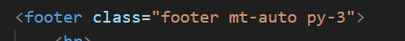

styling the footer.

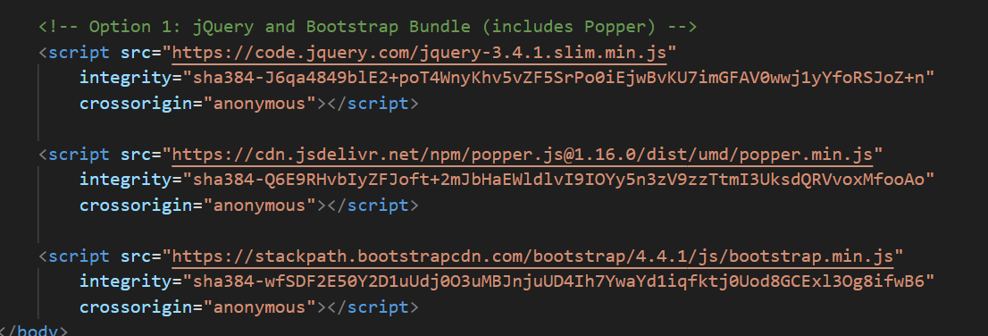

Bootstrap JavaScript and jQuery are included from CDNs to enable Bootstrap features like the navbar toggler and modal.

home.html



gx-4 and gx-lg-5 provide spacing between columns for different screen sizes.

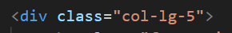

column layout.



img-fluid ensures the image scales properly within its container, rounded adds rounded corners to the image.

# **Task 4 – Overall GUI and working, Report, GIT hub, Video and Reflection**

## Overall Navigational GUI

Overall, the functionality of the navigational GUI is designed to provide users with a seamless experience of navigating the various sections of the online bookstore.

## Working of Web Application meeting all Functionalities

1. Reader registration and login.

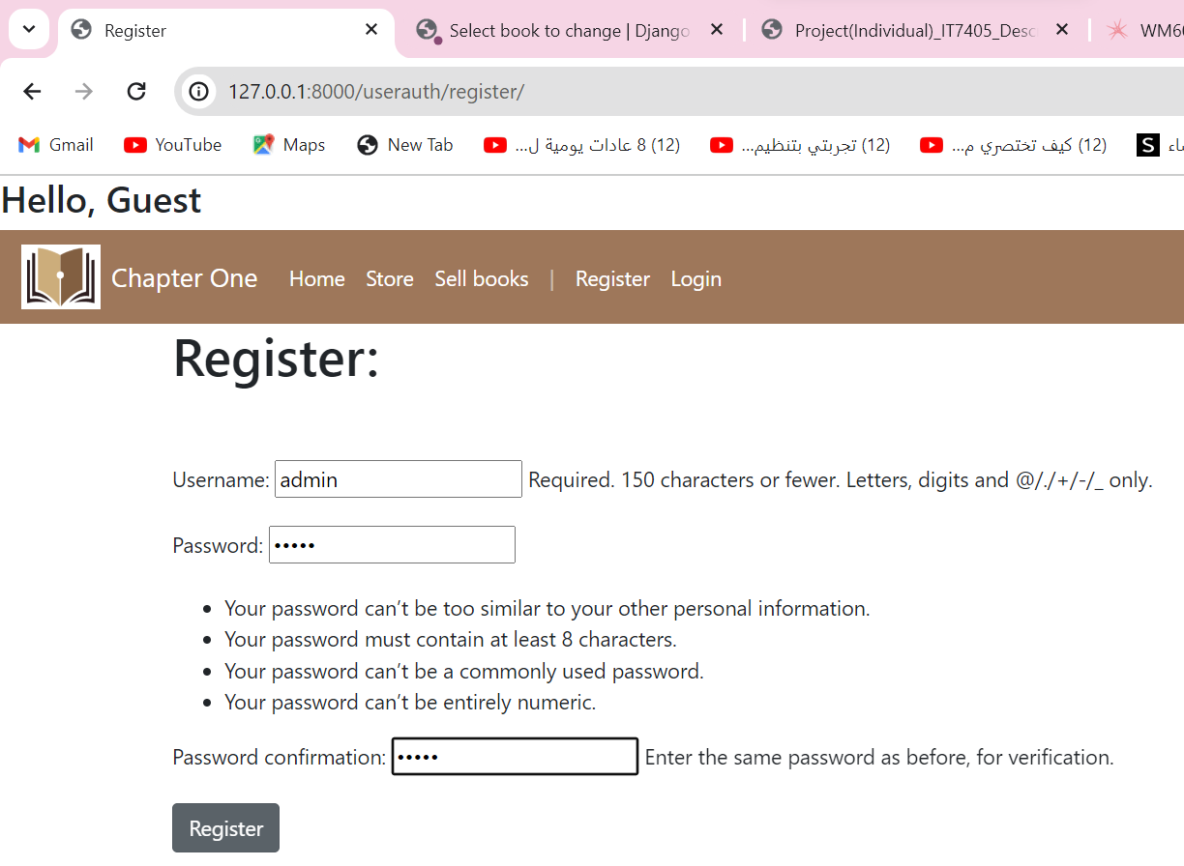

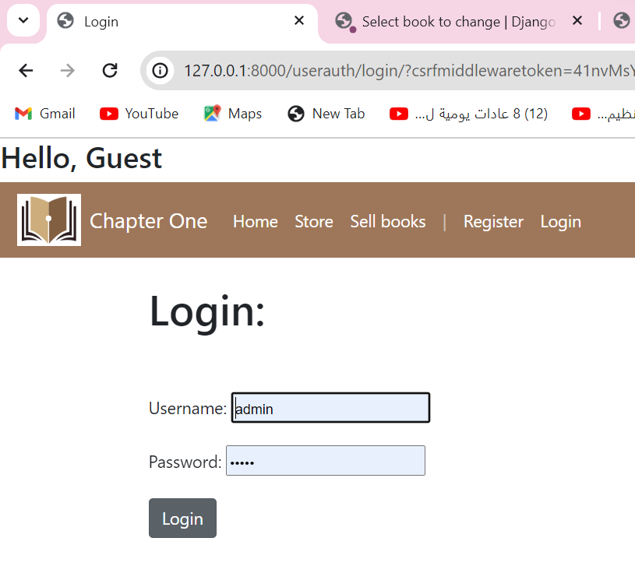

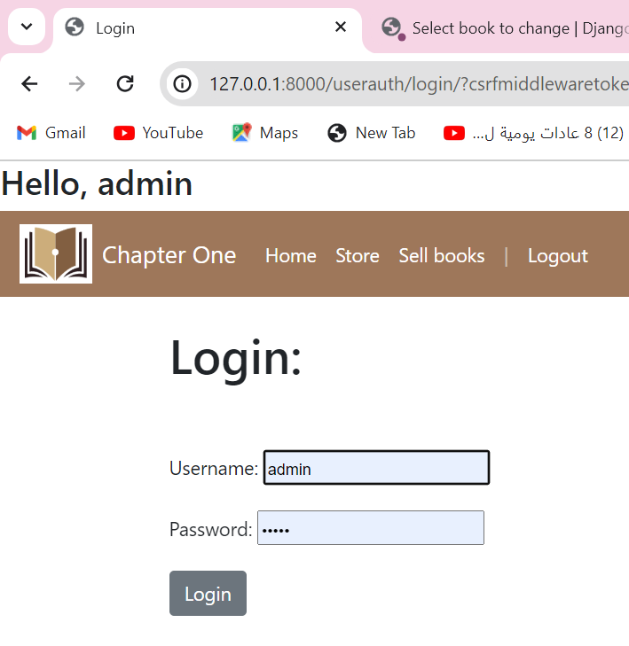

2.      Users can add books to sell and store can also add book, delete, update it.

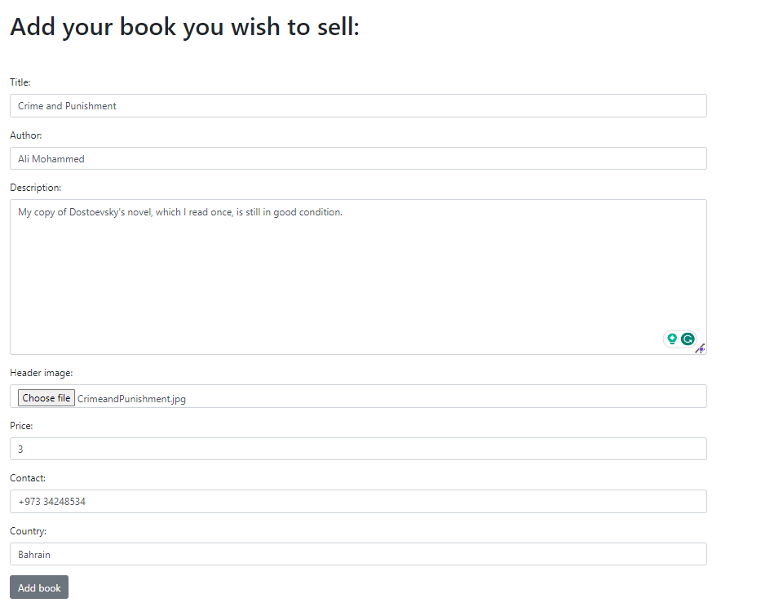



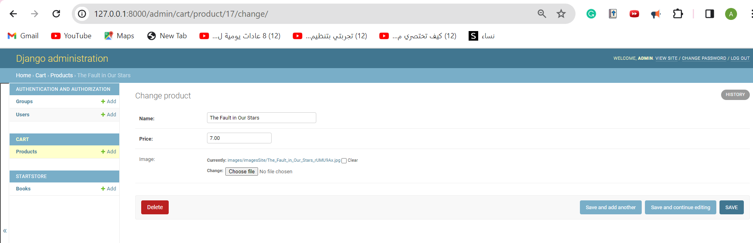

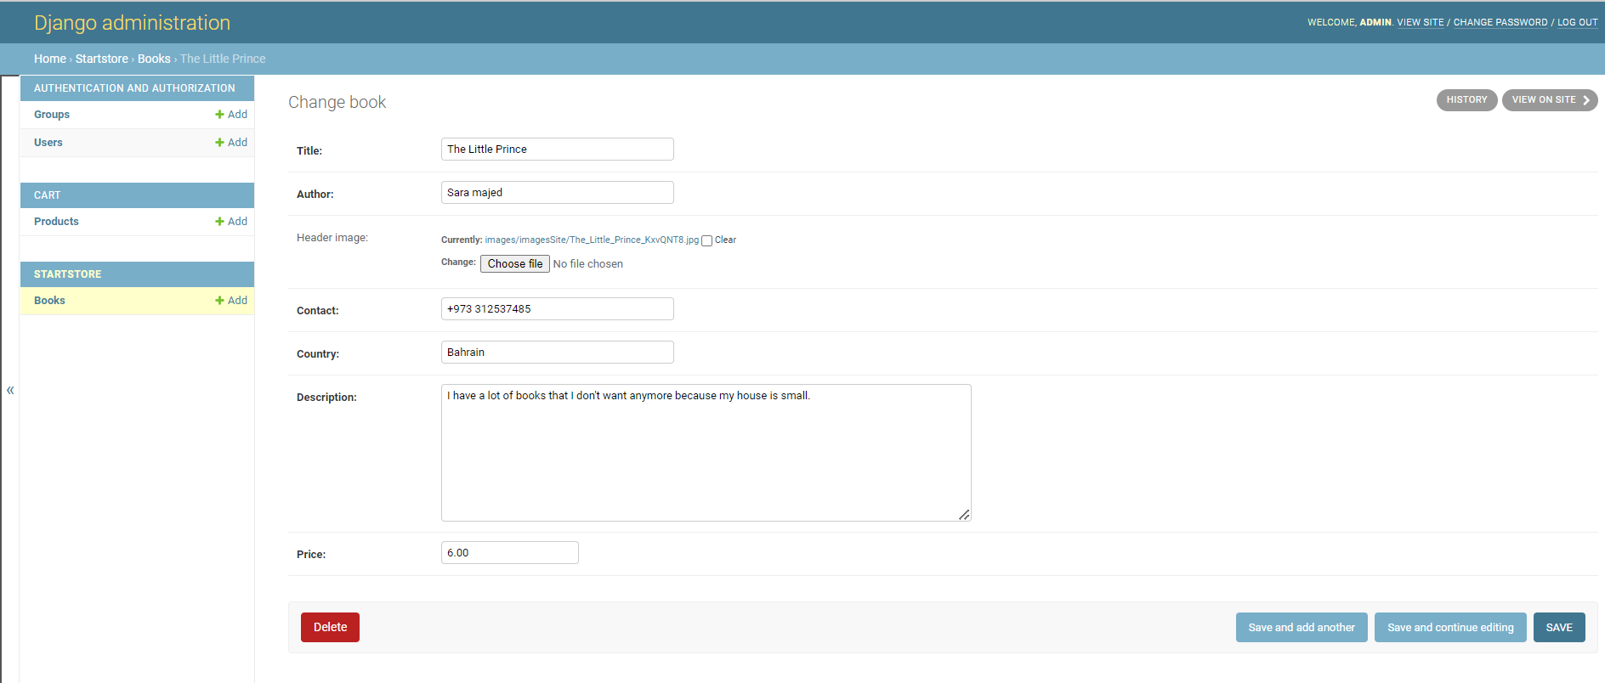

1. Shopping Cart: add to cart, remove from cart, change quantities, and review selections.

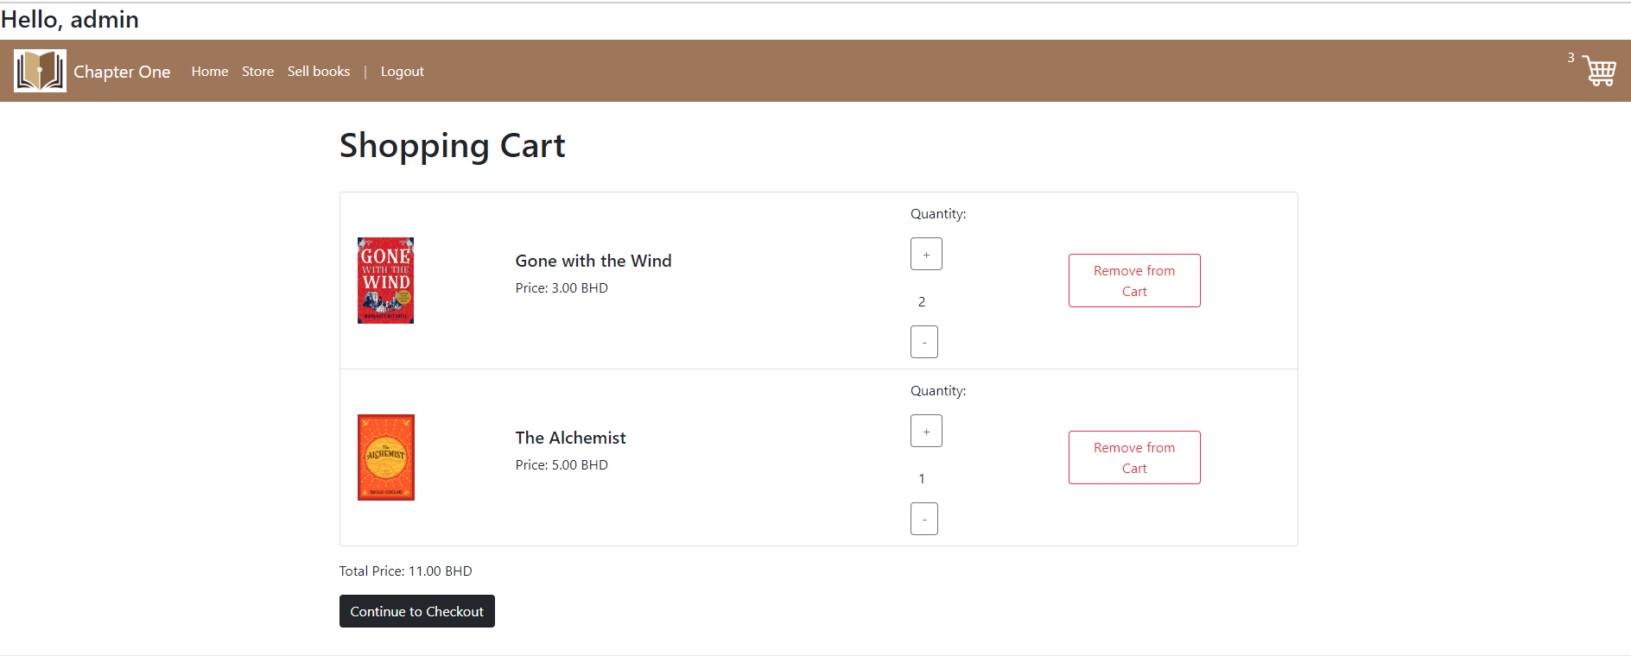

4.      Checkout: entering user data and address to deliver and get a message if purchased successfully.

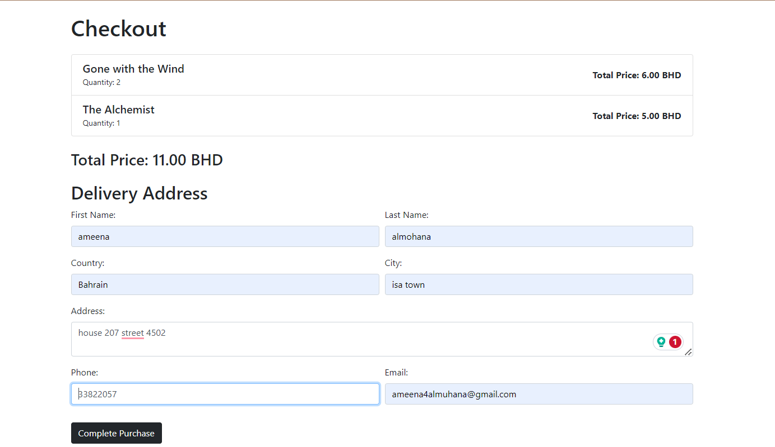

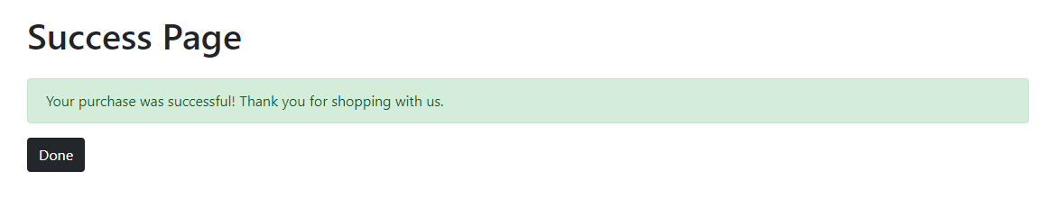

## Report

Done

## GIT hub

<https://github.com/ameena212/ChapterOneBookStore>

## Reflection

Creating an online bookstore using Python, MongoDB, Django, and Bootstrap technologies was both challenging and satisfying. My goal was to design a website that is easy to use by everyone without any problems since this is my first time making a website. However, I overcame several obstacles to complete this project due to my limited experience and limited time. In addition, I gained a lot of knowledge that will assist me in creating a more advanced website, description of the project’s future scope and possible improvements.

One of the problems I faced was time constraints, which remained an issue for me throughout the project because I also had other projects to work on in the same timeframe. Moreover, I faced many errors that wasted my time and energy. In addition to that, I needed to learn by myself how to implement additional functionalities that were not provided in the course material such as add to cart and checkout. Also, designing the website alone needed extra time to choose colors, design the layout and create a unique logo for the store.

I have learned a lot of skills and expertise on how to use new technologies and implement them within a short time when I had to prioritize my tasks. In addition to improving my coding skills, I also developed a strategic approach to managing my time. I also learned how to solve errors which became a significant part of the project. As a result, I have gained flexibility and problem-solving skills in the world of web development. Working with multiple tools at the same time provided me with invaluable knowledge, patience, and ideas for my future career.

The further scope of the project includes improving functionality, design, and scalability. For example, users can choose from multiple payment methods according to their preferences. Moreover, a better user interface could improve the overall user experience. Furthermore, scalability measures should be considered as the business grows. However, I think I could work better if I collaborated with a team to split tasks and ideas, plan the project by having timeline for each part, and write a note solution for each error I get.

In conclusion, regardless of the difficulties, this project has been a rewarding experience for me. My future career in web development will undoubtedly be shaped by the skills I learn during this process. As a result of this experience, I have gained a deeper understanding of the importance of adaptability, endurance, and constant improvement in the technology industry.